**Selenium Notes**

1. ***What is Selenium ?***

Selenium is an open source web automation tool.

**Limitation of Selenium :**

* It doesn’t support windows based application directly. However, third party tool  **(eg: AutoIt)** can be integrated with selenium to automate windows based applications.

**Note :**

1. Selenium community developed specific tool called **WINIUM** to automate windows based applications.
2. Selenium community also developed tools to test mobile applications,

* **Selendroid** - it supports only Android platform
* **Appium** - it supports Android platform, MAC, Windows etc.

**Note :**

All the selenium related resources and documents can be found on the below website.

<http://www.seleniumhq.org>

Here, hq stands for head quarter.

**2*. Why Selenium is so popular and demanding ?***

Selenium is popular and demanding due to the following features.

1. it is an open source tool freely available on internet
2. No project cost involved
3. No licence required
4. Can be easily customized to integrate with other Test Management tools like ALM, Bugzilla etc.
5. It supports almost 13 different software languages

* Java
* C#
* Ruby
* Python
* Perl
* Php
* Javascript
* Javascript (Node JS)
* Haskell
* R
* Dart
* TCL
* Objective - C

   6. It supports almost all the browsers.(Firefox, Chrome, Internet Explorer etc) and

       hence, cross browser testing/compatibility testing can be performed using selenium.

   7. It supports almost all the Operating System (MAC, Windows, LINUX etc) and hence,

    cross platform testing can also be performed.

--------------------------------------------------------------------------------------------------------

***3. What are the different flavours of Selenium ?***

* **Selenium Core** (Developed by a company called **Thought Works** way back in 2004)
* **Selenium IDE** (supports only Mozilla Firefox - supports record and playback feature)
* **Selenium RC** (Remote Control - Version is 1.x) (Used for parallel execution of automation scripts on multiple remote systems)
* **Selenium WebDriver** (Version is 2.x and 3.x)

**Note :**

Selenium WebDriver version 3.x is no longer capable of running Selenium RC directly, rather it does through emulation and via an interface called WebDriverBackedSelenium.

But, **it does support Selenium Grid directly.**

**Selenium Grid :**

1. It is one of the component of selenium that is used to run automation scripts on multiple system simultaneously.
2. It is used to carry out compatibility testing on multiple browsers and platforms.

--------------------------------------------------------------------------------------------------------

***4. What are the key/Important topics of Selenium ?***

* **Automation Framework -** guidelines and rules to write selenium code
* **GitHub** - Central Repository to store code
* **Maven** - build dependency tool for auto update of selenium version
* **Selenium Grid** - to test on multiple OS and browsers
* **Jenkins** - Continuous Integration
* T**estNG** - framework for generation of Test Reports and running multiple test scripts       in one go

--------------------------------------------------------------------------------------------------------

***5. What are the Softwares required for Selenium ?***

1. **Eclipse IDE** - Oxygen (Stable version)
2. **JDK 1.8**
3. **Selenium Server-Standalone**-3.5.3 (Stable version)

*(Download it from the given url :* ***http://www.seleniumhq.org/download****)*

**4.  Driver Executables**

* For Firefox Browser
  + the name of the driver executable is : **geckodriver.exe**
  + Url to download : <https://github.com/mozilla/geckodriver/releases>
  + Version **0.19** is recommended for firefox browser with version 56.0  (selenium jar - 3.5.3)
  + Version **0.18** is recommended for firefox browser with version 54.0 (selenium jar - 3.5.0)
* For Chrome browser
  + the name of the driver executable is :  **chromedriver.exe**
  + Url to download : <https://chromedriver.storage.googleapis.com/index.html?path=2.31/>
  + Stable version of chrome version is 61.0 (Use chromedriver.exe with version 2.33)

**5. Browsers:**

Firefox (Version 54.0) or 56.0 and above version

Chrome (Version 60.0) or 61.0 and above version

**Note :** To stop auto update of firefox browser version, Make sure to disconnect the internet connection and then install 54.0 version, now go to Setting/Option in firefox browser and check the below checkbox - Never check for updates. 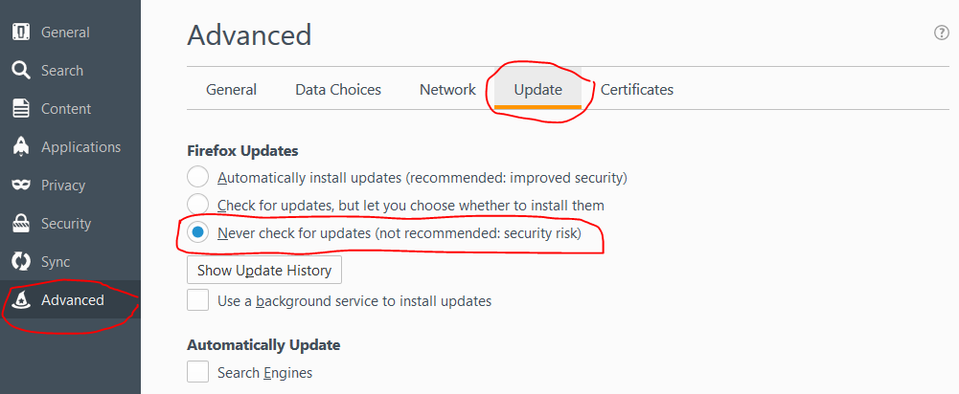

**6. Application Under Test (AUT)**

**Application Name :** actiTIME

**Online url :** [**https://demo.actitime.com/login.do**](https://demo.actitime.com/login.do)

**Offline url :** [**https://localhost:8080/login.do**](https://localhost:8080/login.do)

**To download actiTIME application ,**

[**https://www.actitime.com/download.php**](https://www.actitime.com/download.php)

**--------------------------------------------------------------------------------------------------------**

***6.  Selenium Architecture - High Level ?***

***OR***

***How selenium performs automation testing on browser ?***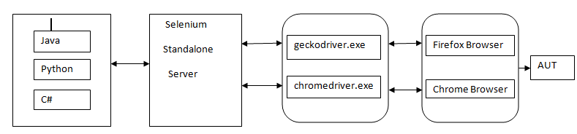

**Client Binding                         Driver Executables               Browser**

**OR                 .jar file              uses**

**Language Binding                                                JSON Wire Protocol**

1. **Since selenium supports multiple languages such as Java, Python, C# etc, we can develop automation scripts in all the supported languages. This is know as language binding or Client binding.**
2. **When we execute the selenium code, request goes to the Selenium Standalone Server (also known as Selenium WebDriver Server), which further process the request based on the input received from the client binding and perform specific actions on the respective browsers using the browser specific driver executables,**

**Eg : geckodriver.exe  for firefox browser and**

**chromedriver.exe for chrome browser and so on…**

**3.  Driver executables uses a protocol called JSON Wire protocol to communicate with related**

**browsers. (JSON stands for Java Script Object Notation)**

**--------------------------------------------------------------------------------------------------------**

***7.  Selenium Java Architecture - Detailed Level***

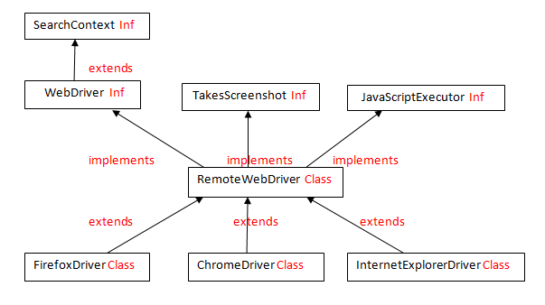

1. **SearchContext is the supermost interface present in selenium webdriver.**
2. **An interface called WebDriver extends SearchContext interface.**
3. **A total of 13 interfaces are available in selenium, which is implemented by a super most class called RemoteWebDriver**
4. **RemoteWebDriver is again extended by few browser specific child classes such as,**

* **FirefoxDriver class to automate on firefox browser.**
* **ChromeDriver class to automate on Chrome browser,**
* **InternetExplorerDriver class to automate on IE and so on…….**

**NOTE :**

All the above mentioned **interfaces and classes** are present in a package called **“org.openqa.selenium”.**

**To view any information about Selenium interfaces, classes and methods, navigate to the below page.**

[**https://github.com/SeleniumHQ/selenium/tree/master/java/client/src/org/openqa/selenium**](https://github.com/SeleniumHQ/selenium/tree/master/java/client/src/org/openqa/selenium)

**Highlighted below in red is the navigation path.**

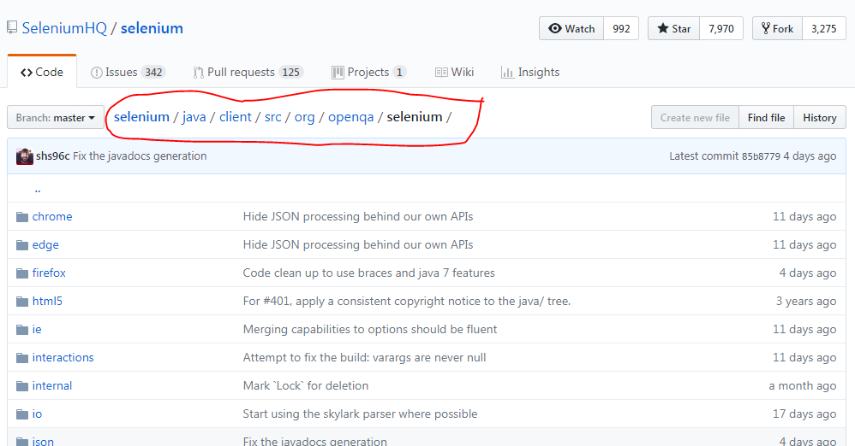

***-------------------------------------------------------------------------------------------***

**8. *List down all the methods present in below interfaces of Selenium WebDriver.***

***Methods of SearchContext interface :***

1. **findElement()**
2. **findElements()**

***Methods of WebDriver interface :***

1. **close()**
2. **get()**
3. **getTitle()**
4. **getPageSource()**
5. **getCurrentUrl()**
6. **getWindowHandle()**
7. **getWindowHandles()**
8. **manage()**
9. **navigate()**
10. **quit()**
11. **switchTo()**

***Methods of TakesScreenshot interface :***

1. **getScreenshotAs(args)**

***Methods of JavascriptExecutor interface :***

1. **executeScript()**
2. **executeAsyncScript()**

***Methods of WebElement  interface :***

1. **clear()**
2. **click()**
3. **getAttribute()**
4. **getCssValue()**
5. **getLocation()**
6. **getRect()**
7. **getSize()**
8. **getTagName()**
9. **getText()**
10. **isDisplayed()**
11. **isEnabled()**
12. **isSelected()**
13. **sendKeys()**
14. **submit()**

**9*. Why we upcast the browser related child class object to WebDriver,  and not RemoteWebDriver class  (RemoteWebDriver being the super most class in selenium) ?***

**Upcasting Example  :**

WebDriver driver = new FirefoxDriver();

* Converting a child class object to super type is called Upcasting.
* In selenium, we use upcasting so that we can execute the same script on any browser.
* In selenium, we can upcast browser object to RemoteWebDriver, WebDriver, TakesScreenshot , JavascriptExecutor etc, but a standard practice is to upcast to WebDriver interface.
* This is as per the Selenium coding standard set by the Selenium community. As a testimonial, navigate to the below selenium community site and check for the text as mentioned in the image below.

Url - <http://www.seleniumhq.org/projects/webdriver/>

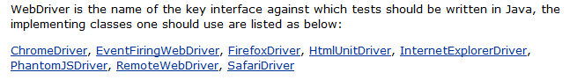

**-------------------------------------------------------------------------------------------**

**10. Where did you use Upcasting in Selenium ?**

*WebDriver driver = new FirefoxDriver();*

**Explain the above statement..**

1. WebDriver is an interface in Selenium that extends the supermost interface called SearchContext.
2. driver is the upcasted object or WebDriver interface reference variable.
3. “ = ” is an assignment operator.
4. new is a keyword using which object of the FirefoxDriver class is created.
5. FirefoxDriver() is the constructor of FirefoxDriver class which initialises the object and it will also launch the firefox browser.

**-------------------------------------------------------------------------------------------**

**11. Steps to install/integrate selenium server to the java project**

1. Launch eclipse and go to package explorer [navigation path :- Window menu → Show View → Package Explorer]
2. Create a java project [File → New→ Java Project]
3. Right click on Java Project and add a new folder with name “driver” [File → New→ Folder]
4. copy **geckodriver.exe** file from your system and paste it  into this driver folder
5. Similarly, create another folder with name **“jar”**and copy **Selenium Standalone Server.jar** file into this jar folder.
6. Expand the jar folder and right click on  **Selenium Standalone Server.jar** file → select **Build Path** → select **Add to Build Path**
7. As soon as you add any .jar files to build path, a new folder will be available called **“Reference Libraries”** under the package explorer section and you can see the .jar file is added to this **“Reference Libraries”**
8. To remove the .jar file from the java build path, go to the Reference Libraries → select the .jar file → right click → select build path → Remove from build path.
9. Other way of adding .jar file to java build path is : right click on the project → build path → configure build path → Libraries tab → Add External jars → select the .jar file → Apply → ok

**12*. This program demonstrates Upcasting concept (FirefoxDriver class object to WebDriver interface) and accessing various methods of WebDriver interface***

**package qspiders;**

**import org.openqa.selenium.WebDriver;**

**import org.openqa.selenium.firefox.FirefoxDriver;**

**public class UpcastingToWebDriver_LaunchBrowser {**

**public static void main(String[] args) throws InterruptedException  {**

**//setting the path of the gecko driver executable**

**System.setProperty("webdriver.gecko.driver", ".\\driver\\geckodriver.exe");**

**//Launch the firefox browser**

**WebDriver driver = new FirefoxDriver();**

**//Enter the url**

**driver.get("http://www.google.com");**

**//Get the title of the google page and print it on the console**

**String title = driver.getTitle();**

**System.out.println("the title of the page is :"+ title);**

**//Get the URL of the google page and print it on the console**

**String currentUrl = driver.getCurrentUrl();**

**System.out.println("the URL of the page is :"+ currentUrl);**

**//Get the source code  of the google page and print it on the console**

**String pageSource = driver.getPageSource();**

**System.out.println("the source code  of the page is :"+ pageSource);**

**//Halt the program execution for 2 seconds**

**Thread.sleep(2000);**

**// Close the browser**

**driver.close();**

**}**

**}**

***7th Oct***

**\*\*\*\*\*\*\*\*\*\*\*\*\*\*\*\*\*\*\*\*\*\*\*\*\*\*\*\*\*\*\*\*\*\*\*\*\*\*\*\*\*\*\*\*\*\*\*\*\*\*\*\*\*\*\*\*\*\*\*\*\*\*\*\*\*\*\*\*\*\*\*\*\*\*\*\*\*\*\*\*\*\*\*\*\*\*\*\*\*\*\*\*\*\*\*\*\*\*\*\*\*\*\*\*\***

***Capturing Screenshot***

**\*\*\*\*\*\*\*\*\*\*\*\*\*\*\*\*\*\*\*\*\*\*\*\*\*\*\*\*\*\*\*\*\*\*\*\*\*\*\*\*\*\*\*\*\*\*\*\*\*\*\*\*\*\*\*\*\*\*\*\*\*\*\*\*\*\*\*\*\*\*\*\*\*\*\*\*\*\*\*\*\*\*\*\*\*\*\*\*\*\*\*\*\*\*\*\*\*\*\*\*\*\*\*\*\***

**Question : How to capture screenshots in Selenium ?**

**Answer : We capture screenshots in Selenium using *getScreenshotAs()* method of  *TakesScreenshot* interface.**

**Steps to take screenshot:**

**1. Create an object of specific browser related class (eg : FirefoxDriver) and then upcast it to WebDriver object (eg : driver)**

**2. Typecast the same upcasted driver object to TakesScreenshot interface type.**

**3. Using the typecasted object, we call getScreenshotAs(OutputType.FILE) which in turn returns the source file object.**

**4. Using the File IO operations (i.e FileUtils class), we store the screenshots to desired location in the project.**

***Selenium Code :***

**package pack1;**

**import java.io.File;**

**import java.io.IOException;**

**import java.util.Date;**

**import org.apache.commons.io.FileUtils;**

**import org.openqa.selenium.OutputType;**

**import org.openqa.selenium.TakesScreenshot;**

**public class CaptureScreenshot_ActiTIMEPage extends BaseClass{**

**public static void main(String[] args) throws IOException {**

***//Creating an object of Date class***

**Date d = new Date();**

***//Printing the actual date***

**String date1 = d.toString();**

**System.out.println(date1);**

**//replacing the colon present in the date timestamp format to "_" using replaceAll()**

**//method of String class**

**String date2 = date1.replaceAll(":", "_");**

**System.out.println(date2);**

***//Enter the url***

**driver.get("**[**https://localhost:8080/login.do**](https://localhost:8080/login.do)**");**

***//Typecasting the driver object to TakesScreenshot interface type.***

**TakesScreenshot ts = (TakesScreenshot) driver;**

***//getting the source file using getScreenshotAs() method and storing in a file***

**File srcFile = ts.getScreenshotAs(OutputType.FILE);**

**/*Created a folder called "screenshot" in the project directory**

**Created another file by concatenating the date value  which has "_" in it**

**(Underscore is the accepted character while creating a file in the project )*/**

**File destFile = new File(".\\screenshot\\"+date2+"__actiTIMELoginPage.png");**

***/*copyFile() method is a static method present in FileUtils class of JAVA***

***storing the screenshot in the destination location*/***

**FileUtils.copyFile(srcFile, destFile);**

**//closing the browser**

**driver.close();**

**}**

**}**

***Question : Why capturing screenshot of the web pages is important in the project ?***

***Answer :***

* **We capture screenshots in order to debug the failed test scripts.**
* **It actually helps the automation test engineer to find the exact root cause of the issue in the application at the earliest.**

***Following are the possible scenarios after the script is failed:***

* **Whenever an automation script is failed, we first manually execute the steps to check whether there is any issue in the application or the issue is with the script.**
* **If the script fails due to an issue in the script itself, we fix the script and re-run it till it is passed.**
* **If there is an issue in the application due to which the script is failed, then we log defect against the same issue. In this way, automation team gets credibility in the project.**

**\*\*\*\*\*\*\*\*\*\*\*\*\*\*\*\*\*\*\*\*\*\*\*\*\*\*\*\*\*\*\*\*\*\*\*\*\*\*\*\*\*\*\*\*\*\*\*\*\*\*\*\*\*\*\*\*\*\*\*\*\*\*\*\*\*\*\*\*\*\*\*\*\*\*\*\*\*\*\*\*\*\*\*\*\*\*\*\*\*\*\*\*\*\*\*\*\*\*\*\*\*\*\*\*\***

***Handling Browser navigation***

**\*\*\*\*\*\*\*\*\*\*\*\*\*\*\*\*\*\*\*\*\*\*\*\*\*\*\*\*\*\*\*\*\*\*\*\*\*\*\*\*\*\*\*\*\*\*\*\*\*\*\*\*\*\*\*\*\*\*\*\*\*\*\*\*\*\*\*\*\*\*\*\*\*\*\*\*\*\*\*\*\*\*\*\*\*\*\*\*\*\*\*\*\*\*\*\*\*\*\*\*\*\*\*\*\***

***Question : How to navigate within the browser ?***

**Answer : Using navigate() methods.**

**public class BrowserNavigationExample {**

**public static void main(String[] args) throws InterruptedException {**

**System.setProperty("webdriver.gecko.driver", ".\\driver\\geckodriver.exe");**

**WebDriver driver = new FirefoxDriver();**

**//Enter the url**

**driver.get("http://localhost:8080/login.do");**

**driver.navigate().to("http://www.gmail.com");**

**Thread.sleep(3000);**

**driver.navigate().back();**

**Thread.sleep(3000);**

**driver.navigate().forward();**

**Thread.sleep(3000);**

**driver.navigate().refresh();**

**driver.close();**

**}**

**}**

**\*\*\*\*\*\*\*\*\*\*\*\*\*\*\*\*\*\*\*\*\*\*\*\*\*\*\*\*\*\*\*\*\*\*\*\*\*\*\*\*\*\*\*\*\*\*\*\*\*\*\*\*\*\*\*\*\*\*\*\*\*\*\*\*\*\*\*\*\*\*\*\*\*\*\*\*\*\*\*\*\*\*\*\*\*\*\*\*\*\*\*\*\*\*\*\*\*\*\*\*\*\*\*\*\***

***Handling Mouse and Keyboard Operations***

**\*\*\*\*\*\*\*\*\*\*\*\*\*\*\*\*\*\*\*\*\*\*\*\*\*\*\*\*\*\*\*\*\*\*\*\*\*\*\*\*\*\*\*\*\*\*\*\*\*\*\*\*\*\*\*\*\*\*\*\*\*\*\*\*\*\*\*\*\*\*\*\*\*\*\*\*\*\*\*\*\*\*\*\*\*\*\*\*\*\*\*\*\*\*\*\*\*\*\*\*\*\*\*\*\***

***Question : How to handle mouse movement and keyboard Operations ?***

**Answer :**

* ***We handle mouse movement in Selenium using mouseMove() method of Robot Class.***
* ***Similarly, to handle keyboard operations, we use KeyPress() and KeyRelease() methods of Robot Class***

***Selenium Code to demonstrate an example of Mouse movement and Keyboard operation :***

**package test;**

**import java.awt.AWTException;**

**import java.awt.Robot;**

**import java.awt.event.KeyEvent;**

**import org.openqa.selenium.WebDriver;**

**import org.openqa.selenium.firefox.FirefoxDriver;**

**public class Keyboard_Mouse_Operations {**

**public static void main(String[] args) throws InterruptedException, AWTException {**

**System.setProperty("webdriver.gecko.driver", ".\\driver\\geckodriver.exe");**

**//1. Launch the browser**

**WebDriver driver = new FirefoxDriver();**

**//2. enter the url -**

**driver.navigate().to("http://localhost:8080/login.do");**

**Thread.sleep(5000);**

**//Creating an object of Robot Class**

**Robot r = new Robot();**

**//move the mouse by x and y coordinate**

**r.mouseMove(300, 500);**

**//press ALT key from keyboard**

**r.keyPress(KeyEvent.VK_ALT);**

**//press F key from keyboard**

**r.keyPress(KeyEvent.VK_F);**

**//Release F key from keyboard**

**r.keyRelease(KeyEvent.VK_F);**

**//Release Alt key from keyboard**

**r.keyRelease(KeyEvent.VK_ALT);**

**Thread.sleep(3000);**

**//Press W key from keyboard to open a new private window**

**r.keyPress(KeyEvent.VK_W);**

**//Release W key from keyboard**

**r.keyRelease(KeyEvent.VK_W);**

**Thread.sleep(3000);**

**// It will close only the current browser window**

**//driver.close();**

**// It will close all the browser windows opened by Selenium**

**driver.quit();**

**}}**

**\*\*\*\*\*\*\*\*\*\*\*\*\*\*\*\*\*\*\*\*\*\*\*\*\*\*\*\*\*\*\*\*\*\*\*\*\*\*\*\*\*\*\*\*\*\*\*\*\*\*\*\*\*\*\*\*\*\*\*\*\*\*\*\*\*\*\*\*\*\*\*\*\*\*\*\*\*\*\*\*\*\*\*\*\*\*\*\*\*\*\*\*\*\*\*\*\*\*\*\*\*\*\*\*\***

***Identification of WebElements using Locators***

**\*\*\*\*\*\*\*\*\*\*\*\*\*\*\*\*\*\*\*\*\*\*\*\*\*\*\*\*\*\*\*\*\*\*\*\*\*\*\*\*\*\*\*\*\*\*\*\*\*\*\*\*\*\*\*\*\*\*\*\*\*\*\*\*\*\*\*\*\*\*\*\*\*\*\*\*\*\*\*\*\*\*\*\*\*\*\*\*\*\*\*\*\*\*\*\*\*\*\*\*\*\*\*\*\***

***What is an WebElement ?***

**1. Any element present on a web page is called as web element.**

**2. Developers use HTLM code to develop web pages.**

**3. For testing purpose, we can also create web page using HTML code.**

**4. In order to create a web page, we need to write HTML code in any text pad (eg : notepad and save the file with .html extension)**

***Create a sample web page using HTML as mentioned below.***

**<html>**

**<body>**

**UN : <input type="text" id = "username" value = "admin">**

**PWD: <input type="text" id= "pass" value = "manager">**

**<a href="http://localhost:8080/login.do"> Click ActiTIME Link</a>**

**</body>**

**</html>**

***In the above HTML tree, every element should have one of the 3 options.***

1. **Tagname (this is mandatory for all the elements)**
2. **Attributes (Optional)**
3. **Text (Optional)**

***Example  of Tagname in the above HTML Tree structure:***

* **html,**
* **body,**
* **input,**
* **a**

***Example of Attributes in the above HTML Tree structure:***

* **type = "text"**
* **id = “username”**
* **value = "admin"**

***Format :* attributeName = “attributeValue”**

***Example of Text in the above HTML Tree structure:***

* **Click ActiTIME link**

***What are Locators  ?***

* **Locators are used to identify the web elements on the web page.**
* **We have 8 types of locators in Selenium using which findElement() methods identifies   elements on the web page:**

1. **id**
2. **name**
3. **tagName**
4. **className**
5. **linkText**
6. **partialLinkText**
7. **xpath**
8. **cssSelector**

* **findElement() method returns the address of the web elements on the web page and the return type is WebElement.**
* **If the specified locators returns multiple elements, then findElement() method returns the address of the first matching element.**
* **If the specified locators returns No element, then findElement() method throws an exception called "NoSuchElementException".**

**Note :**

**In below Selenium code snippet,**

**WebDriver driver = new FirefoxDriver();**

1. **driver.findElement(By.id(""));**
2. **driver.findElement(By.name(""));**
3. **driver.findElement(By.tagName(""));**
4. **driver.findElement(By.class(""))**
5. **driver.findElement(By.linkText(""))**
6. **driver.findElement(By.partialLinkText(""))**
7. **driver.findElement(By.xpath(""))**
8. **driver.findElement(By.cssSelector(""))**

**1. (By is an abstract class and all the locators specified/highlighted above are static methods of By class and hence, we call directly by using <classname.staticConcrete> methods**

**Below is the code to demonstrate the usage of locators in selenium while identifying the web elements on the web page:**

**package pack1;**

**import org.openqa.selenium.By;**

**import org.openqa.selenium.WebDriver;**

**import org.openqa.selenium.WebElement;**

**import org.openqa.selenium.firefox.FirefoxDriver;**

**public class LocatorsExample{**

**public static void main(String[] args) throws InterruptedException {**

**System.setProperty("webdriver.gecko.driver", ".\\driver\\geckodriver.exe");**

**WebDriver driver = new FirefoxDriver();**

***// Enter the URL of your own created sample web page***

**driver.get("file:///C:/Users/admin/Desktop/UN.html");**

***// Used “id” locator to find USERNAME text box***

**WebElement unTB = driver.findElement(By.id("user"));**

***//Clear the existing value present in the text box***

**unTB.clear();**

***// Enter value into the USERNAME text box***

**unTB.sendKeys("ajit.biswas@gmail.com");**

***// Used “name” locator to find Password text box***

**WebElement passTB = driver.findElement(By.name("n1"));**

***//Clear the existing value present in the text box***

**passTB.clear();**

***//Halt the program execution for 2 seconds***

**Thread.sleep(2000);**

***// Enter value into the Password text box***

**passTB.sendKeys("Qspiders123");**

***// Find the address of ActiTIME Link and click***

**driver.findElement(By.linkText("Click ActiTIME link")).click();**

**Thread.sleep(2000);**

**}}**

***Important notes on LinkText and PartialLinkText locator***

* **Out of all the locators, linkText and PartialLinkText are used to identify only the links present on the webpage.(elements whose tagname is “a” -- a stands for anchor)**
* **LinkText locator should be used when the text of the link is constant**
* **PartialLinkText locator should be used when certain part of the link text is getting changed everytime the page is loaded. i.e for partially dynamically changing text, we use partialLinkText locator**
* **To handle those elements whose text changes completely, we can’t use partialLInkText locator. It should be handled by another locator called “xpath”**
* **If we use try to use these 2 locators on other type of elements (except Links), then we get “NoSuchElementException”**

***Steps to install firebug and firepath add-ons in Firefox browser :***

1. **We need to install firebug and firepath addons in firefox browser to write cssSelector expression and then evaluate whether the expression is correct or not.**
2. **To install firebug addon in firefox browser :**

**TOOLS -- > ADD-ONS → EXTENSIONS → search firebug -- > and click on Install -- Restart the browser.**

**3. To install firepath addon in firefox browser :**

**TOOLS -- > ADD-ONS → EXTENSIONS → search firepath -- > and click on Install -- Restart the browser.**

***Steps to write and evaluate cssSelector expression in firefox browser :***

1. **Navigate to the web page -- > right click anywhere on the web page → select inspect element with firebug  or Press F12 from keyboard.**
2. **Go to firepath tab and select CSS option.**
3. **Type the cssSelector expression and hit Enter key from the keyboard, it will highlight the corresponding matching element on the web page.**

***Steps to write and evaluate cssSelector expression in Chrome browser :***

1. **In order to write cssSelector expression in chrome browser, we don’t need any add-ons as such.**
2. **Navigate to the web page -- > right click anywhere on the web page → Press F12 from keyboard or select inspect element, it will open the Developer tool section with Elements tab selected by default.**
3. **Press Ctrl+F and write the cssSelector expression, it will  highlight the source code of the matching  element.**
4. **Place the cursor on the highlighted source code, it will highlight the corresponding element present on the web page.**

**cssSelector locator :**

1. **It is one of the locator in Selenium using which we identify web elements on the web page.**
2. **It stands for Cascading Style Sheet.**
3. **The standard syntax for cssSelector expression is**

**tagName[attributeName = ‘attributeValue’]**

**OR**

**here, tagName is not mandatory.**

**[attributeName = “attributeValue”]**

***Sample Element html code for Login button:***

**<input type=”textbox” id= “ID123” class = “inputText” value=”Login”>**

**Following are the 4 different ways of writing cssSelector expression for above mentioned Login button :**

**CssSelector Expression using type as an attribute :: input[type=’textbox’]**

**Actual code to identify Login button using FindElement() method:**

**driver.findElement(By.cssSelector(“input[type=’textbox’]”))**

**------------------------------------------------------------------------------**

**CssSelector Expression using id as an attribute : input[id=’ID123’]**

**Actual code to identify Login button using FindElement() method:**

**driver.findElement(By.cssSelector(“input[id=’ID123’]”))**

**----------------------------------------------------------------------------**

**CssSelector Expression using class as an attribute  : input[class=’inputText’]**

**Actual code to identify Login button using FindElement() method:**

**driver.findElement(By.cssSelector(“input[class=’inputText’]”))**

**------------------------------------------------------------------------------------------**

**CssSelector Expression using value as an attribute  : input[value=’Login’]**

**Actual code to identify Login button using FindElement() method:**

**driver.findElement(By.cssSelector(“input[value=’Login’]”))**

**---------------------------------------------------------------------------------------------**

**Important Note :**

**While deriving cssSelector expression, we can use either one attribute or multiple attributes till we found unique matching element on the web page.**

**eg : input[type=’textbox’][id=’ID123’][class=’inputText’][value=’Login’]**

**4. CssSelector can also be written using ID and Class. Here, ID is represented by “ # ” and className is represented by dot operator( . )**

***Sample Element html code for Login button:***

**<input type=”textbox” id= “ID123” class = “inputText” value=”Login”>**

**4.1 CssSelector expression for the above Login button can be written using ID as**

**input#ID123   (syntax = Tagname#id)**

**OR**

**#ID123  (syntax = #id) [note : tagname is not mandatory]**

**Actual code to identify Login button using FindElement() method is below :**

**driver.findElement(By.cssSelector(“#ID123”))**

**4.2  CssSelector expression for the above Login button can be written using ID as shown below**

**input.inputText  (syntax = tagname.classname)**

**OR**

**“.inputText”  (syntax = .classname) [note : tagname is not mandatory]**

**Actual code to identify Login button using FindElement() method:**

**driver.findElement(By.cssSelector(“.inputText”))**

***Limitation of cssSelector :***

1. **It does not support text i.e we can identify element using text of the element.**
2. **It does not support backward traversing.**
3. **It doesn’t support index**

***XPATH :***

1. **xpath is one of the locator in selenium using which we identify objects or elements on the web page and perform specific actions to carry out automation testing.**
2. **xpath is the path of an element in the html tree.**
3. **xpath are of 2 types.**

**3.1)  Absolute xpath**

**3.2)  Relative xpath**

**Absolute xpath :**

1. **It refers to the path of the element right from the root node to the destination element.**
2. **While writing the absolute xpath, We use single forward slash (/) to traverse through each immediate child element in the html tree.**

**3.    In the below sample html tree,**

**document**

**|_____html**

**|**

**---- body**

**|**

**------> a**

**Absolute xpath can be written in the following ways.**

**html/body/a**

**or**

**./html/body/a**

**(Note :- here, dot (.) refers to the current document or the current web page, using dot here is optional)**

**4. Using absolute xpath in selenium code as shown below.**

**driver.findElement(By.xpath(“html/body/a”)).click();**

**5. In xpath, if there are multiple siblings with same tagname, then the index starts from 1.**

**6.In case of multiple siblings with same tagname, if we don’t use index, then it considers ALL the siblings.**

**7. We can join multiple xpath using pipeline operator ( | )**

**Considering the below sample html tree, write Absolute xpath and Relative xpath expressions.**

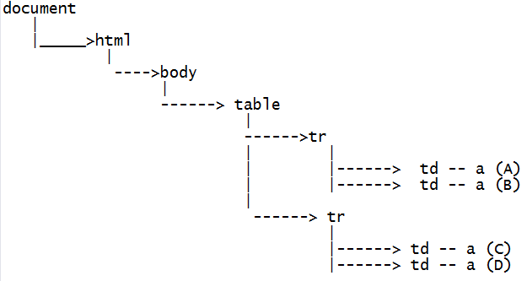

**Fill in the table with Absolute xpath expressions using the sample html tree given above.**

|  |  |
| --- | --- |
| **Absolute xpath expressions** | **Matching Element** |
|  | **A** |
|  | **B** |
|  | **C** |
|  | **D** |
|  | **AB** |
|  | **CD** |
|  | **AC** |
|  | **BD** |
|  | **AD** |
|  | **BC** |
|  | **ABC** |
|  | **ABD** |
|  | **ABCD** |

**Relative xpath :**

1. **In Absolute xpath, we write the path of the element right from the root node and hence, the expression for absolute xpath is lengthy.**
2. **In order to reduce the length of the expression, we go for Relative xpath.**
3. **In Relative xpath, we use double forward slash ( // ), which represents any descendant.**

**Fill in the table with relative xpath expressions using the sample html tree given above.**

|  |  |
| --- | --- |
| **Relative xpath expressions** | **Matching Element** |
|  | **A** |
|  | **B** |
|  | **C** |
|  | **D** |
|  | **AB** |
|  | **CD** |
|  | **AC** |
|  | **BD** |
|  | **AD** |
|  | **BC** |
|  | **ABC** |
|  | **ABD** |
|  | **ABCD** |

***Interview questions :***

1. **what is the difference between ‘/’ and ‘//’ ?**

**Answer : “/” refers to the immediate child element in the html tree.**

**“//” refers to any element in the html tree. It also represent any descendant.**

**2. What are the types of xpath?**

**Ans:  Absolute and Relative xpath.**

**3. Derive an xpath which matches all the links present on a web page ?**

**Ans : //a**

**4. Derive an xpath which matches all the image present on a web page ?**

**Ans : //img**

**5. Derive an xpath which matches all the links and images present on a web page ?**

**Ans : //a | //img**

**6. Derive an xpath which matches all the 2nd links present on a web page ?**

**//a[2]**

**7. Derive an xpath which matches all the links present inside a table present on a web page ?**

**//table//a**

**8. Difference between “//a”and “//table//a “ ?**

**Ans : //a → refers to all the links present on the webpage.**

**//table//a → refers to all the links present within all the tables present on the webpage.**

**xpath by Attribute :**

1. **xpath expression can be written using attribute of the web element.**
2. **Based on the situation, we would use either single attribute or multiple attributes to find an element on a web page.**
3. **Using single attribute in xpath expression, if it returns one matching element, then we would use single attribute only.**
4. **In case,  by using single attribute in xpath expression, if it returns multiple matching elements on the web page, then we would go for using multiple attributes in the xpath expression till we get one matching element.**

**xpath expression using Attribute :**

1. **using single attribute :**

**Syntax :   //tagname[@attributeName = ‘attributeValue’]**

**//tagname[ NOT(@attributeName = ‘attributeValue’)]**

**Sample application : actiTIME application**

**url :** [**https://demo.actitime.com/login.do**](https://demo.actitime.com/login.do)

**Write xpath for below few elements on above actiTIME login page :**

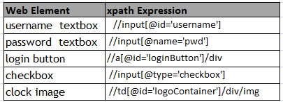

**Usage in selenium code :**

**driver.findElement(By.xpath(“paste any xpath here from above table”))**

1. **Using multiple attribute :**

**xpath Syntax :**

* **//tagName[@AN1=’AV1’][ @AN2=’AV2’]**
* **//tagName[@AN1=’AV1’] | //tagName[@AN2=’AV2’]**

**Element : View licence link**

**html code after inspecting the element using F12 key:**

**<a id="licenseLink" target="" href="javascript:void(0)" onclick="openLicensePopup();">View License</a>**

**xpath expression using “href” and “onclick” attributes :**

**//a[@href='javascript:void(0)' and @onclick='openLicensePopup();']**

**Usage in selenium code :**

**driver.findElement(By.xpath(“//a[@href='javascript:void(0)']**

**[@onclick='openLicensePopup();']”))**

**Assignment :**

**Write xpath expression for below 7 elements present on actiTIME login page**

**Elements :**

1. **UserName**
2. **Password**
3. **Login Button**
4. **Check box**
5. **Actitime Image**
6. **View Licence link**
7. **actiTIME Inc link**

**Use the below format  (Sample example for actiTIME Inc Link):**

**html code for <actiTIME Inc.> :**

**<a href="http://www.actitime.com" target="_blank">actiTIME Inc.</a>**

**xpath syntax**

//tagname[@AN1 = 'AV1']

**1. using href attribute:**

//a[@href = 'http://www.actitime.com']

**2. using target attribute**

//a[@target = '_blank']

**Note: Use all the attributes of an element to write xpath expression**

**xpath expression using text() function :**

1. In the html code of an element, if attribute is duplicate or attribute itself is not present, then use text() function to identify the element.
2. In order to use text() function, the element should have text in the element’s html code.

    Syntax :

//tagName[text()=’text value of the element’]

                OR

//tagName[.=’text value of the element’]

**Note :** Instead of text(), we can use dot (.) , the problem here with using dot (.) is sometimes,

         it returns the hidden element also present on the webpage. which might confuse the

         user. So the best practice is to use text() instead of using dot.

xpath expression using text() function for below elements present on actiTIME login page.

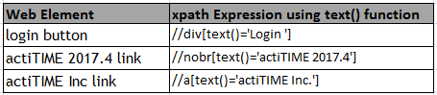

**xpath expression using contains() function :**

1. In the html code of an element, if the attribute value or the text is changing partially, then use contains() function to identify the element.
2. In order to use contains() function, the element should have either attribute value or text value.

    Syntax :

* //tagName[contains(@attributeName,’attributeValue’)]
* //tagName[contains(text(),’text value of the element’)]

**xpath expression using contains() function for below elements present on actiTIME login page.**

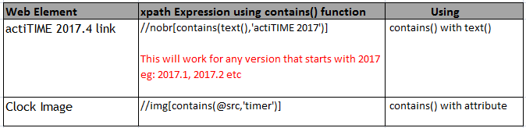

3. We use contains() function when the text value is very lengthy or the attribute value is very lengthy.

**eg:** xpath to identify error message present on actitime login page (  Click on login button without entering username and password to get the error message)

//span[contains(text(),'invalid')]

**Program to illustrate xpath by attributes, text() function, contains() function and their usages with attributes and text values.**

public class XpathUsingAttribute_Actitime extends BaseClass{

    public static void main(String[] args) throws InterruptedException {

System.setProperty("webdriver.gecko.driver", ".\\driver\\geckodriver.exe");

        WebDriver driver = new FirefoxDriver();

*//Enter the url of actiTIME application*

        driver.get("http://localhost:8080/login.do");

*//xpath using multiple attributes*

        String xp = "//input[@class='textField'][ @id = 'username']";

        Thread.sleep(2000);

*//Enter admin into username text box*

        driver.findElement(By.xpath(xp)).sendKeys("admin");

        Thread.sleep(2000);

*//find password element using xpath by attribute and enter manager in to password textbox.*

        driver.findElement(By.xpath("//input[@name='pwd']")).sendKeys("manager");

        Thread.sleep(2000);

*//find an image on the web page whose attributes (src)contains a value called timer*

WebElement clock = driver.findElement(By.xpath("//img[contains(@src,'timer')]"));

*//store the width value of the clock image into a variable called widthValue*

        String widthValue = clock.getAttribute("width");

*//Print the width of the clock image*

        System.out.println("the width is :"+widthValue);

*//Print the height of the clock image*

System.out.println("the height of the clock element is : "+ clock.getAttribute("height"));

*//xpath using text() function*

        driver.findElement(By.xpath("//div[text()='Login ']")).click();

        Thread.sleep(2000);

*//xpath using contains() function and text() function*

driver.findElement(By.xpath("//a[@id='loginButton']//div[contains(text(),'Login')]")).click();

        Thread.sleep(2000);

        driver.close();

    }

}

***xpath expression using starts-with() function :***

1. We use starts-with() function to identify those elements whose text value  starts with some specified value.

*xpath using* ***contains()*** *function:*

**//[contains(text(),'actiTIME')]** - this xpath will return 6 matching element on login page of actiTIME application.

*xpath using* ***starts-with()*** *function,*

**//[starts-with(text(),'actiTIME')]** - this xpath will return only 3 matching element on login page of actiTIME application as the text value of these 3 elements starts with “actiTIME” text

**Handling completely dynamic links :**

1. When the text value of the elements is completely changing, then we can’t use functions like “contains()”, “starts-with()” etc to handle those elements.
2. In such cases, we identify the dynamically changing element using the nearby unique element. We call this concept as independent dependent xpath.

**Steps to derive xpath expression using Independent dependent concept :**

1. Identify the independent element on the webpage and inspect the element to view the source code and then derive the xpath expression.
2. Place your cursor on the independent element source code and move the mouse pointer upward till it highlights both the independent and dependent elements which is the common parent element.

    Add  /.. to the xpath of independent element already noted down in step 1 to

get the xpath of common parent.

   3.  Use mouse pointer to navigate from common parent to the desired dependent

    element and derive the xpath of the dependent element.

  4.    Write the xpath from Independent element to Common parent and then write

    the xpath from Common parent to dependent element.

**Example 1:**

Write xpath to identify **version** of Java Language present in Selenium Download page.

**//td[.='Java']/../td[2]**

**Example 2:**

Write xpath to identify **Release data**  of Java Language present in Selenium Download

page.

//td[.='Java']/../td[3]

**Example 3:**

Write xpath to identify **Download link**  of Java present in Selenium Download

page.

//td[.='Java']/../td[4]/a

Note :

* In case, if the column number of **Download link** changes, then the above xpath will fail to identify the link as we are hard coding the column position as 4 in the above case.

In order to handle this, we will write xpath in such a way that it works irrespective of the column position as shown below.

//td[.='Java']/..//a[.='Download']

Program 1 :

Write a script to click on the download link of Java in Selenium website

Scenario :

1. Login in to Selenium official website

        Url : [http://](http://localhost:8080/login.do)www.seleniumhq.org/download

1. Click on the Download link for Java language.

public class Independent_Dependent_Xpath_Seleniumsite_javaDownload{

       public static void main(String[] args) throws InterruptedException {

System.setProperty("webdriver.gecko.driver", ".\\driver\\geckodriver.exe");

      WebDriver driver = new FirefoxDriver();

    // enter the url

         driver.get("http://www.seleniumhq.org/download/");

      Thread.sleep(3000);

    // xpath using independent and dependent concept

       driver.findElement(By.xpath("//td[.='Java']/..//a[.='Download']")).click();

    }

}

**Group Index :**

**Sample Html tree :**

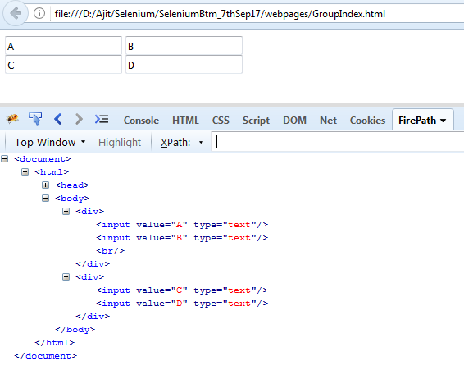

**xpaths using Group Index to identify the elements in the above sample tree:**

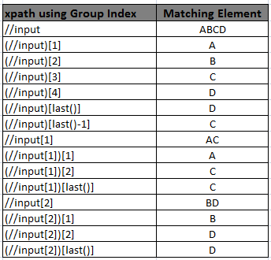

1. In Group index, we write xpath expression within the braces  and then we write the index outside the braces.
2. Internally, it executes the xpath expression first and stores the result in an xpath array whose index starts with 1
3. last() is a function that is used to retrieve the last element present in the xpath array.

Program 2 :

Click on the **Set by default** link of **testing** present in **type of work (Setting tab)** of actiTIME application

Scenario :

1. Login in to actime application

        Url : <http://localhost:8080/login.do>

        UN - admin, PWD - manager

1. click on Settings
2. Click on the Types of Work link present in the window
3. click on the Set by Default link for a type of work called “testing”

**Use the below hints :**

1. Use groupIndex concept to find **Setting** Element and
2. Independent and dependent concept to find **Set by Default** link

public class Xpaths_Independent_dependent_actitime_setbydefault {

   public static void main(String[] args) throws InterruptedException {

    System.setProperty("webdriver.gecko.driver", ".\\driver\\geckodriver.exe");

      WebDriver driver = new FirefoxDriver();

      driver.get("http://localhost:8080/login.do");

       driver.findElement(By.id("username")).sendKeys("admin");

      driver.findElement(By.name("pwd")).sendKeys("manager");

    //click on ***login*** button

      driver.findElement(By.xpath("//div[.='Login ']")).click();

      Thread.sleep(4000);

//Click on ***settings*** tab on home page driver.findElement(By.xpath("(//div[@class='popup_menu_label'])[1]")).click();

         Thread.sleep(2000);

    //Click on ***Types of Work*** link

         driver.findElement(By.xpath("//a[.='Types of Work']")).click();

      Thread.sleep(4000);

    //Click on ***testing*** link present under ***Type of work*** column

driver.findElement(By.xpath("//a[.='testing']/../..//a[.='set by default']")).click();

      driver.close();

    }

}

Create a html file as shown below.

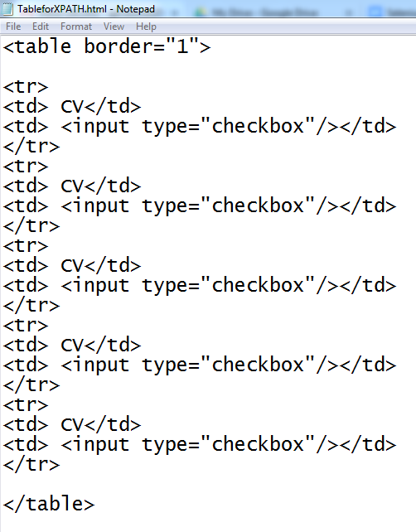

Xpath expression using GroupIndex concept :

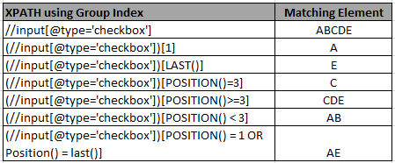

**Xpath Axes :**

1. In xpath, navigating from one element to another element is called ***traversing***.
2. In order to traverse from one element to another, we use xpath axes.
3. We have the following 6 xpath axes in selenium.

* child
* descendant
* parent
* ancestor
* preceding-sibling
* following-sibling

Create a .html file with the below html code

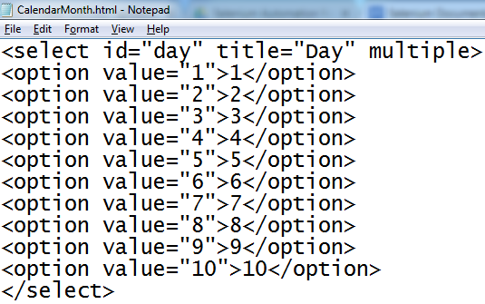

Following are the syntax to use all the xpath axes in Selenium.

***child Axes:***

eg : /html → can be written using ***child*** axes as →  child::html

***descendant Axes:***

eg : //option[5] → can be written using ***descendant*** axes as → descendant::option[5]

***parent Axes:***

eg : //option[5]/.. → can be written using ***parent*** axes as → descendant::option[5]/parent::select

***ancestor Axes:***

eg : //option[5]/../.. → can be written using ancestor axes as → descendant::option[5]/ancestor::body

***preceding-sibling Axes:***

eg : → xpath using ***preceding-sibling*** axes  → descendant::option[5]/preceding-sibling::option[1]  - it will select 4 in the list box

***following-sibling Axes:***

eg : → xpath using ***following-sibling*** axes  → descendant::option[5]/following-sibling::option[1]  - it will select 6 in the list box

***Following table illustrates a detailed level understanding of all the xpath axes :***

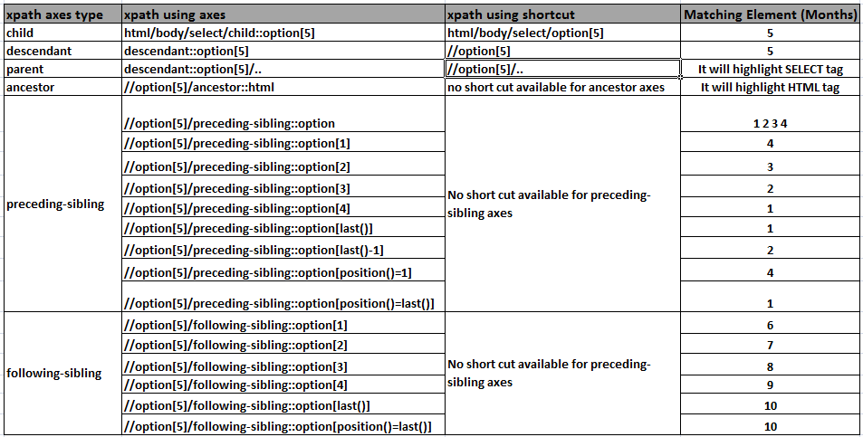

**Difference between CssSelector and Xpath**

|  |  |
| --- | --- |
| **CssSelector** | **Xpath** |
| It is faster | It is slower |
| text() function is not supported | text() function is supported |
| backward traversing is not supported | backward traversing is supported |
| groupIndex is not supported | groupIndex is supported |

**Imp Note :**

**In CssSelector, we traverse through the element using this symbol “ > ”**

Interview Questions :

How do you ensure the required page is displayed or not ?

We can use following checkpoints to validate the required page is displayed or not.

1. using title of the page
2. using URL of the page
3. using any unique element on the page

*Write a program to validate Actitime application home page using TITLE of the page*

public class VerifyhomepageUsingTitle {

        public static void main(String[] args) throws InterruptedException {

System.setProperty("webdriver.gecko.driver", ".\\driver\\geckodriver.exe");

        WebDriver driver = new FirefoxDriver();

        driver.get("http://localhost:8080/login.do");

         driver.findElement(By.id("username")).sendKeys("admin");

        driver.findElement(By.name("pwd")).sendKeys("manager");

        driver.findElement(By.xpath("//div[.='Login ']")).click();

        Thread.sleep(3000);

        String expectedTitle = "Enter Time";

        String actualTitle = driver.getTitle();

        //If actual title contains "Enter Time" text then home page is displayed.

        if (actualTitle.contains(expectedTitle)) {

        System.out.println("Home page is displayed");

        } else{

        System.out.println("Home page is NOT displayed");

        }

    }

}

*Write a program to validate Actitime application home page using* ***Current URL*** *of the page*

public class VerifyhomepageUsingUrl {

    public static void main(String[] args) throws InterruptedException {

    System.setProperty("webdriver.gecko.driver", ".\\driver\\geckodriver.exe");

        WebDriver driver = new FirefoxDriver();

         driver.get("http://localhost:8080/login.do");

         driver.findElement(By.id("username")).sendKeys("admin");

         driver.findElement(By.name("pwd")).sendKeys("manager");

         driver.findElement(By.xpath("//div[.='Login ']")).click();

         Thread.sleep(3000);

         String expectedUrl = "submit";

         String actualUrl = driver.getCurrentUrl();

         if (actualUrl.contains(expectedUrl)) {

         System.out.println("Home page is displayed");

        } else{

        System.out.println("Home page is NOT displayed");

        }

    }

}

*Write a program to validate Actitime application home page using* ***any UNIQUE element*** *on the page*

public class VerifyhomepageUsingUniqueElement {

    public static void main(String[] args) throws InterruptedException {

    System.setProperty("webdriver.gecko.driver", ".\\driver\\geckodriver.exe");

    WebDriver driver = new FirefoxDriver();

    driver.get("http://localhost:8080/login.do");

    driver.findElement(By.id("username")).sendKeys("admin");

    driver.findElement(By.name("pwd")).sendKeys("manager");

    driver.findElement(By.xpath("//div[.='Login ']")).click();

    Thread.sleep(3000);

    WebElement logoutBtn = driver.findElement(By.xpath("//a[.='Logout']"));

    if (logoutBtn.isDisplayed()) {

    System.out.println("Home page is displayed");

    } else{

    System.out.println("Home page is NOT displayed");

    }

}

}

*Write a program to validate Username and Password fields on Actitime login page are aligned or not ?*

public class VerifyUNandPWDalignment extends BaseClass{

    public static void main(String[] args) {

        driver.get("http://localhost:8080/login.do");

        WebElement unTB = driver.findElement(By.id("username"));

        int un_x = unTB.getLocation().getX();

        int un_width = unTB.getSize().getWidth();

        int un_height = unTB.getSize().getHeight();

        WebElement pwTB = driver.findElement(By.name("pwd"));

        int pw_x = pwTB.getLocation().getX();

        int pw_width = pwTB.getSize().getWidth();

        int pw_height = pwTB.getSize().getHeight();

        if (un_x == pw_x && un_width==pw_width && un_height==pw_height) {

            System.out.println("Username and password text box are aligned");

        } else {

            System.out.println("Username and password text box are NOT aligned");

        }

    }

}

**Assignment :**

*Write a program to validate Username and Password fields on* ***Facebook login page*** *are aligned or not ?*

public class VerifyFB_UNandPWDfieldsAreAligned_intheSameRow {

    public static void main(String[] args) throws InterruptedException {

System.setProperty("webdriver.gecko.driver", ".\\driver\\geckodriver.exe");

        WebDriver driver = new FirefoxDriver();

        driver.get("https://www.facebook.com/");

        WebElement unTB = driver.findElement(By.id("email"));

        // get the y-coordinate of ***username*** field

        int username_Ycordinate = unTB.getLocation().getY();

        System.out.println(username_Ycordinate);

        WebElement pwdTB = driver.findElement(By.name("pass"));

        // get the y-coordinate of ***password*** field

        int password_Ycordinate = pwdTB.getLocation().getY();

        System.out.println(password_Ycordinate);

//check whether the Y-coordinate of **username and**  ***password*** field are same

        if (username_Ycordinate==password_Ycordinate) {

System.out.println("Both username and password fields are displayed in the same row");

        }else{

System.out.println("username and password fields are NOT aligned in the same row");

        }

    }

}

*Write a program to validate* ***the height and width of Username and Password*** *fields on* ***Facebook login page*** *are same or not ?*

public class VerifyActime_UNandPassword_HeightandWidth {

    public static void main(String[] args) throws InterruptedException {

System.setProperty("webdriver.gecko.driver", ".\\driver\\geckodriver.exe");

        WebDriver driver = new FirefoxDriver();

        driver.get("<http://localhost:8080/login.do>");

        //find the username field

        WebElement unTB = driver.findElement(By.id("username"));

        //store the height of username

        int username_height = unTB.getSize().getHeight();

        //store the width of username

        int username_width = unTB.getSize().getWidth();

        System.out.println(username_height);

        System.out.println(username_width);

        //find the password field

        WebElement pwdTB = driver.findElement(By.name("pwd"));

        //store the height of password

        int password_height = pwdTB.getSize().getHeight();

        //store the width of password

        int password_width = pwdTB.getSize().getWidth();

        System.out.println(password_height);

        System.out.println(password_width);

        //check the height and width of username and password fields are same

        if (username_height==password_height && username_width==password_width) {

System.out.println("Username and password fields are aligned”);

        }else{

System.out.println("Username and password fields are NOT aligned");

        }

        }

    }

}

*Write a script to validate that* ***the username  field*** *on* ***Facebook login page*** *is* ***smaller*** *than the* ***Mobile Number field*** *?*

public class VerifyFB_Usernamefield_lessthanMobileNumberField {

    public static void main(String[] args) {

        System.setProperty("webdriver.gecko.driver", ".\\driver\\geckodriver.exe");

        WebDriver driver = new FirefoxDriver();

        driver.get("https://www.facebook.com/");

        WebElement unTB = driver.findElement(By.id("email"));

        int username_width = unTB.getSize().getWidth();

        System.out.println(username_width);

        //Identify the mobile number text box

WebElement mobileNumTB = driver.findElement(By.xpath("//input[contains(@aria-label,'Mobile number or email address')]"));

        int mobNumWidth = mobileNumTB.getSize().getWidth();

        System.out.println(mobNumWidth);

        //Compare the width of both username and mobilenumber text box

        if (username_width==mobNumWidth) {

System.out.println("Size of Both username and password fields are same" +username_width+" = " + mobNumWidth);

        }else{

System.out.println("Size of username and password fields are NOT same that is : " +username_width+" Not equals to " + mobNumWidth);

        }

    }

}

*Interview Question :*

***Write a script to enter a text into the focussed element (eg : textbox).***

public class EnterTextintoFocussedElement {

    public static void main(String[] args) throws InterruptedException {

System.setProperty("webdriver.gecko.driver", ".\\driver\\geckodriver.exe");

        WebDriver driver = new FirefoxDriver();

        driver.get("<http://localhost:8080/login.do>");

        //entering text into the focussed element

        driver.switchTo().activeElement().sendKeys("admin");

    }

}

*How do you remove value present in username text box of Actitime application ?*

Using **clear()** method of WebElement interface.

**Selenium code :**

public class RemoveValuefromText_usingClearMethod{

    public static void main(String[] args) throws InterruptedException {

        driver.get("http://localhost:8080/login.do");

        driver.findElement(By.id("username")).sendKeys("ajit");

        Thread.sleep(2000);

        String value = driver.findElement(By.id("username")).getAttribute("value");

        System.out.println("Value present inside the text box is : "+value);

        driver.findElement(By.id("username")).clear();

        Thread.sleep(2000);

        driver.findElement(By.id("username")).sendKeys("againEnteredAjit");

        Thread.sleep(2000);

 driver.findElement(By.id("username")).sendKeys(Keys.CONTROL+"a"+Keys.DELETE); // this line will actually delete the value if there is no space in the text entered

// if there is a space between two words in the username field, we have to use the below lines of code

driver.findElement(By.id("username")).sendKeys(Keys.CONTROL+"a") ;

driver.findElement(By.id("username")).sendKeys(Keys.DELETE);

        Thread.sleep(2000);

        }

}

*How do you remove value present in username text box of Actitime application without using clear() method ?*

Using **sendKeys()** method of WebElement interface.

**Selenium code :** *driver.findElement(By.id("username")).****sendKeys(Keys.CONTROL + "a" + Keys.DELETE);***

public class RemoveValuefromText_usingClearMethod{

    public static void main(String[] args) throws InterruptedException {

        driver.get("http://localhost:8080/login.do");

        driver.findElement(By.id("username")).sendKeys("ajit");

        Thread.sleep(2000);

        String value = driver.findElement(By.id("username")).getAttribute("value");

        System.out.println("Value present inside the text box is : "+value);

        driver.findElement(By.id("username")).clear();

        Thread.sleep(2000);

        driver.findElement(By.id("username")).sendKeys("againEnteredAjit");

        Thread.sleep(2000);

***driver.findElement(By.id("username")).sendKeys(Keys.CONTROL+"a"+Keys.DELETE);***

        Thread.sleep(2000);

        }

}

*Write a script to print the* ***tooltip text*** *of the checkbox present on the login page of  Actitime application ?*

Using **getAttribute()** method of WebElement interface.

**Selenium code below :**

public class PrintTooltip_Actitime_RememberCheckbox {

    public static void main(String[] args) {

        System.setProperty("webdriver.gecko.driver", ".\\driver\\geckodriver.exe");

        WebDriver driver = new FirefoxDriver();

        driver.get("<http://localhost:8080/login.do>");

*//find the Keep me Logged in Checkbox*

        WebElement Checkbox = driver.findElement(By.id("keepLoggedInCheckBox"));

*//get the tooltip text using getAttribute() method and store in a variable*

        String tooltipText = Checkbox.getAttribute("title");

        System.out.println(tooltipText);

        driver.close();

    }}

*Write a script to check “Keep me Logged in” checkbox on  the login page of  Actitime application is selected or not ?*

Using **isSelected()** method of WebElement interface.

**Selenium code below :**

public class CheckBox_selectedorNot{

    public static void main(String[] args) {

        driver.get("<http://localhost:8080/login.do>");

WebElement KeepMeLogIN_Checkbox = driver.findElement(By.name("remember"));

//select the checkbox

        KeepMeLogIN_Checkbox.click();

        /Using the **isSelected()** method, it checks whether the checkbox is selected or

        not :   if it is already selected, it return true and if not selected, then it returns

false/

        if (KeepMeLogIN_Checkbox.isSelected()) {

            System.out.println("Checkbox is selected");

        }else{

            System.out.println("Checkbox is NOT selected");

        }

    }

}

*Write a script to check* ***“Username”*** *textbox on  the login page of  Actitime application is enabled or not ?*

Using **isEnabled()**method of WebElement interface.

**Selenium code below :**

public class VerifyUNtextboxisEnabledinActitime {

    public static void main(String[] args) {

        driver.get("http://localhost:8080/login.do");

        WebElement UN = driver.findElement(By.id("username"));

        if (UN.isEnabled()) {

            System.out.println("Username text box is enabled");

        }else {

            System.out.println("Username text box is disabled");

        }

        driver.close();

    }

}

*Write a script to* ***print the version*** *of actitime on  login page of  Actitime application*

Using **getText()**method of WebElement interface.

**Selenium code below :**

public class PrintVersion_ActitimeLoginPage extends BaseClass{

        public static void main(String[] args) {

        driver.get("http://localhost:8080/login.do");

        String xpathforVersion = "//nobr[contains(text(),'actiTIME')]";

        String version = driver.findElement(By.xpath(xpathforVersion)).getText();

        System.out.println("Version of actitime on login page is : " + version);

    }

}

*Write a script to verify that* ***View License link*** *on login page of  Actitime application is a link or not ?*

Using **getTagName()**method of WebElement interface.

**Selenium code below :**

public class VerifyViewLicense_isaLinkOnActitimepage extends BaseClass {

        public static void main(String[] args) {

        driver.get("http://localhost:8080/login.do");

        String tagName = driver.findElement(By.id("licenseLink")).getTagName();

        if (tagName.equals("a")) {

            System.out.println("View LIcence is a link");

        } else{

            System.out.println("View LIcence is NOT a link");

        }

        driver.close();

    }

}

*Write a script to verify that* ***KeepMeLoggedIn checkbox*** *on login page of  Actitime application is a checkbox or not ?*

Using **getAttribute()**method of WebElement interface.

**Selenium code below :**

public class VerifyKeepMeLoggedInisaCheckboxinActitime extends BaseClass{

    public static void main(String[] args) {

    driver.get("<http://localhost:8080/login.do>");

String elementType = driver.findElement(By.id("keepLoggedInCheckBox")).getAttribute("type");

    System.out.println(elementType);

    if (elementType.equalsIgnoreCase("checkbox")) {

        System.out.println("it is a checkbox");

    }else{

    System.out.println("it is NOT  a checkbox");

    }}}

*Write a script to  demonstrate different options to* ***click on a button or  on a link (Or any element)***

Using the below  methods of WebElement interface.

1. click()
2. sendkeys()
3. submit()

**Selenium code below :**

public class diffwaysofClickingonaButton{

    public static void main(String[] args) throws InterruptedException {

        System.setProperty("webdriver.gecko.driver", "./driver/geckodriver.exe");

        WebDriver driver = new FirefoxDriver();

        driver.get("https://demo.vtiger.com");

        String xp = "//button[.='Sign in']";

*//1. using click() method*

        driver.findElement(By.xpath(xp)).click();

*//2. using sendkeys*

        driver.findElement(By.xpath(xp)).sendKeys(Keys.ENTER);

*/3. using submit() method*

*this method will work only and only if if the element has an attribute called type= 'submit'/*

        driver.findElement(By.xpath(xp)).submit();

    }}

*Write a script to verify the* ***color of the error message*** *on Actitime login page when user clicks on Login button without entering username and password ?*

Using **getCssValue()**method of WebElement interface.

**Selenium code below :**

public class VerifyErrormessageonActimeloginpage {  
    public static void main(String[] args) {  
        System.setProperty("webdriver.gecko.driver", ".\\driver\\geckodriver.exe");  
        WebDriver driver = new FirefoxDriver();  
        driver.get("http://localhost:8080/login.do");  
        *//click on Login button*   
        driver.findElement(By.xpath("//div[.='Login ']")).click();  
        *//find the error message element*  
        WebElement errMsg =

              driver.findElement(By.xpath("//span[contains(.,'invalid')]"));    
        *// get the text of the error message*  
        String errtext = errMsg.getText();  
        *//print the error message*  
        System.out.println("error message is :"+errtext);  
        *//get the value of color and store  in a variable*  
        String c = errMsg.getCssValue("color");  
        *//convert the color from string type to hexa form*  
        String ColorasHex = Color.fromString(c).asHex();  
        System.out.println("hexadecimal format : "+ColorasHex);

    if(ColorasHex.equals(“#ce0100”)){

    System.out.println(“Error message is in red color”);

    }else{

    System.out.println(“Error message is in red color”);

}

*//get the size of the font of error message*  
        String fontSize = errMsg.getCssValue("font-size");  
        *//get the weight of the font of error message*  
        String fontWeight = errMsg.getCssValue("font-weight");  
        System.out.println("Size of the font is :" + fontSize);  
        System.out.println("Weight of the font is :" + fontWeight);  
        driver.close();  
            }  
}

**JavascriptExecutor**

It is one of the interface in selenium which has below 2 methods.

1. executeScript()
2. executeAsyncScript()

We use JavascriptExecutor when we fail to perform some actions using selenium.

*Write a script to* ***enter a text*** *in a* ***textbox*** *which is in* ***disabled mode*** *?*

Using **sendKeys()** of **WebElement *interface****,  if we try to enter, we get* ***InvalidElementStateException***

Using **executeScript()** of ***JavascriptExecutor*** *interface, we can enter text in a disabled textbox.*

Create a sample webpage using the below html source code wherein the second textbox is disabled as shown below.

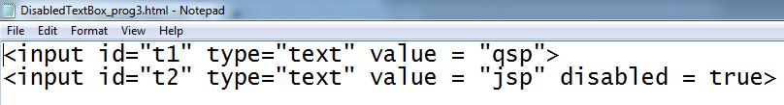

**The webpage looks like this.**

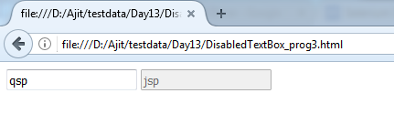

**Selenium code below :**

public class *enterText_intoDisabledTextbox* {

    public static void main(String[] args) throws InterruptedException {

        System.setProperty("webdriver.gecko.driver", ".\\driver\\geckodriver.exe");

        WebDriver driver = new FirefoxDriver();

        driver.get("file:///D:/Ajit/testdata/Day13/DisabledTextBox_prog3.html");

*//Typecast the driver object to JavascriptExecutor interface type*

        JavascriptExecutor js = (JavascriptExecutor) driver;

        Thread.sleep(2000);

*//enter "****admin****" in first textbox using javascript*

        js.executeScript("document.getElementById('t1').value='admin'");

        Thread.sleep(2000);

*//****clear*** *the value in second textbox using javascript*

        js.executeScript("document.getElementById('t2').value=''");

*//enter "****manager****" in second textbox using javascript*

        js.executeScript("document.getElementById('t2').value='manager'");

*//change the second* ***text box to button*** *type using Javascript*

        js.executeScript("document.getElementById('t2').type='button'");

    }}

*what are the usage of  JavascriptExecutor ?*

1. to scroll on the webpage.
2. to handle the disabled elements
3. to use as an alternate solution when selenium inbuilt methods (  eg : clear(), click(), sendKeys() ) doesn’t work

In Selenium, we don’t have any method to scroll up or down on the webpage, in such case, we can use **JavascriptExecutor.**

*Steps to run javascript manually on browser webpage*

1. Open the required page in the browser and press F12 from keyboard.
2. Navigate to Console tab, type the javascript statement and press Enter key

*Write a script to* ***scroll up and down*** *on Selenium official website*

Using executeScript() of *JavascriptExecutor interface*

**Selenium code below :**

**public class ScrollUpandDown {**

**public static void main(String[] args) throws InterruptedException {**

**System.setProperty("webdriver.gecko.driver", ".\\driver\\geckodriver.exe");**

**WebDriver driver = new FirefoxDriver();**

**driver.get("**[**http://seleniumhq.org/download**](http://seleniumhq.org/download)**");**

***//typecasting driver object to JavascriptExecutor interface type***

**JavascriptExecutor js = (JavascriptExecutor) driver;**

**for (int i = 1; i < 10; i++) {**

***//scroll down on the webpage***

**js.executeScript("window.scrollBy(0, 1000)");**

**Thread.sleep(3000);**

**}**

**for (int i = 1; i < 10; i++) {**

***//scroll up on the webpage***

**js.executeScript("window.scrollBy(0, -1000)");**

**Thread.sleep(3000);**

**}}}**

*Write a script to* ***scroll down to a specific element  (Applitool webelement )*** *on Selenium official website*

Using executeScript() of *JavascriptExecutor interface*

**Selenium code below :**

public class ScrollUpandDowntospecificElementonWebpage {

    public static void main(String[] args) throws InterruptedException {

        System.setProperty("webdriver.gecko.driver", ".\\driver\\geckodriver.exe");

        WebDriver driver = new FirefoxDriver();

        driver.get("<http://seleniumhq.org/download>");

        //click on the close icon  of the yellow color background pop up

        driver.findElement(By.id("close")).click();

        // find the Applitools element on the webpage

WebElement ele = driver.findElement(By.xpath("//img[contains(@src,'applitools')]"));

// get the X-coordinate and store in a variable

        int x = ele.getLocation().getX();

        // get the Y-coordinate and store in a variable

        int y = ele.getLocation().getY();

        JavascriptExecutor js = (JavascriptExecutor) driver;

        //Scroll to Applitools element’s  x and y coordinate

        js.executeScript("window.scrollBy("+x+", "+y+")");

        Thread.sleep(3000);

    }}

***Assignment :*** *Write a script to scroll down to the bottom of the page ?*

Using **executeScript() of *JavascriptExecutor*** *interface*

**Selenium code below :**

public class NavigatetoBottomofthePage {

    public static void main(String[] args) throws InterruptedException {

        System.setProperty("webdriver.gecko.driver", ".\\driver\\geckodriver.exe");

        WebDriver driver = new FirefoxDriver();

        driver.get("http://www.seleniumhq.org/download/");

        driver.findElement(By.id("close")).click();

        //select an element which is present at the bottom of the page

        WebElement element = driver.findElement(By.id("footerLogo"));

        int x = element.getLocation().getX();

        int y = element.getLocation().getY();

        System.out.println("X coordinate is :"+x + " and Y coordinate is :"+ y);

        JavascriptExecutor js = (JavascriptExecutor) driver;

        js.executeScript("window.scrollBy("+x+","+y+")");

        Thread.sleep(3000);

        element.click();

    }}

*************************************************************************************************************************

***HANDLING FRAMES***

*************************************************************************************************************************

What is frame ?

1. Webpage present inside another webpage is called embedded webpage.
2. In order to create frame or embedded webpage, developer uses a tag called **iframe.**
3. In order to perform any operation on any element present inside a frame, we first have to switch the control to frame.
4. We switch to frame using the below statement

    driver.switchTo().frame(arg);

      5. frame() is an overloaded method which accepts the following arguments.

*frame(index)*

*frame(id)*

*frame(name)*

*frame(WebElement)*

6.  If the specified frame is not present, we get an exception called “NoSuchFrameException”

 7. In order to exit from the frame, we use the following statements.

    driver.switchTo().defaultContent(); → it will take you to the main page

    driver.switchTo().parentFrame(); → it will take you to the immediate parent frame

8.   Easiest way to verify that an element is present within a frame is to right click on the element and verify that **this frame** option is displayed in the context menu.

Create a sample webpage using the below html source code and save the file as Page1.html

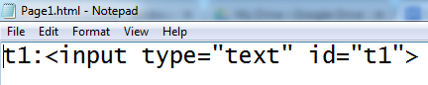

Create another sample webpage using the below html source code and save the file as Page2.html

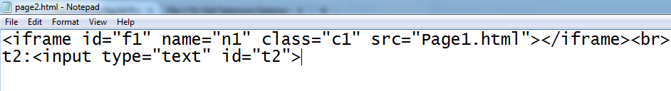

*The webpage looks like this. Here, t1 is inside the frame and t2 is outside the frame on the webpage*

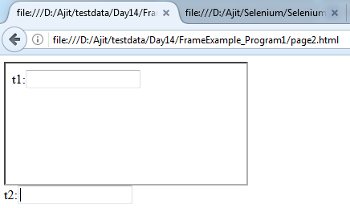

*Write a script to enter a text into an element which is present inside a frame ?*

**Selenium code:**

public class Frame_Demo{

    public static void main(String[] args) {

        System.setProperty("webdriver.gecko.driver", ".\\driver\\geckodriver.exe");

        WebDriver driver = new FirefoxDriver();

driver.get("file:///D:/Ajit/Selenium/SeleniumBtm_7thSep17/webpages/Frame_Page2.html");

        //using index of the frame - **[ int value] [ index of frames starts with zero]**

        driver.switchTo().frame(0);

        driver.findElement(By.id("t1")).sendKeys("a");

        driver.switchTo().defaultContent();

        driver.findElement(By.id("t2")).sendKeys("a");

        //using id attribute of the frame -string

        driver.switchTo().frame("f1");

        driver.findElement(By.id("t1")).sendKeys("b");

        driver.switchTo().defaultContent();

        driver.findElement(By.id("t2")).sendKeys("b");

        //using name attribute of the frame -string

        driver.switchTo().frame("n1");

        driver.findElement(By.id("t1")).sendKeys("c");

        driver.switchTo().defaultContent();

        driver.findElement(By.id("t2")).sendKeys("c");

        //using address of the frame -webelement

        WebElement f = driver.findElement(By.className("c1"));

        driver.switchTo().frame(f);

        driver.findElement(By.id("t1")).sendKeys("d");

        driver.switchTo().defaultContent();

        driver.findElement(By.id("t2")).sendKeys("d");

        driver.close();

    }

}

***ACTIONS Class :***

*How do you handle* ***Context Menu*** *in Selenium ?*

***OR***

*Write a script to right click on* ***“ActiTIME Inc.”*** *link on actitime login page and then open it in  new window ?*

*Using* ***contextClick()*** *method of Actions class*

**Selenium code:**

public class ContextClickusingActionsClass {

***//ContextClick does not work on firefox browser - pls do it on chromebrowser***

    public static void main(String[] args) throws AWTException, InterruptedException {

        System.setProperty("webdriver.chrome.driver", ".\\driver\\chromedriver.exe");

        //open the browser

        WebDriver driver = new ChromeDriver();

        //enter the url

        driver.get("http://localhost:8080/login.do");

        //find the ActiTIME Inc. link

        WebElement link = driver.findElement(By.linkText("actiTIME Inc."));

        //right click (context click) on actitime link

        Actions actions = new Actions(driver);

        actions.contextClick(link).perform();

        Thread.sleep(3000);

        //press 'w' from the keyboard for opening in a new window

        Robot r = new Robot();

        r.keyPress(KeyEvent.VK_W);

        r.keyRelease(KeyEvent.VK_W);

        //quit() method closes all the browsers opened by Selenium

        driver.quit();

    }}

**Imp Note :**

*Whenever we call any method of Actions class, we have to explicitly call perform() method of Actions class. Otherwise, it will not perform any action on the browser.*

***Assignment :***

Automate the following scenario using contextClick() method of Actions Class.

***Scenario Steps :***

1. ***Login in to gmail***
2. ***Based on the subject of a mail, Right click on the mail***
3. ***Select Archive option***

***Selenium Code:***

public class gmail_contextClickDemo_mailArchive {

    public static void main(String[] args) throws InterruptedException {

        System.setProperty("webdriver.chrome.driver", ".\\driver\\chromedriver.exe");

        WebDriver driver = new ChromeDriver();

        driver.get("https://www.gmail.com");

*//enter email id*

driver.findElement(By.xpath("//input[@type='email']")).sendKeys("enter your username");

        //click on Next button

        driver.findElement(By.xpath("//span[.='Next']")).click();

        Thread.sleep(3000);

        //enter password id

        driver.findElement(By.xpath("//input[@type='password']")).sendKeys("enter ");

        //click on Next button

        driver.findElement(By.xpath("//span[.='Next']")).click();

        Thread.sleep(10000);

        //Write xpath expression for the mail item based on a subject

        String xp = "(//b[contains(.,'Following Openings (for Bangalore)')])[2]";

        //get the address of the mail item which you want to archive

        WebElement mail = driver.findElement(By.xpath(xp));

        //print the subject of the mail

        System.out.println(mail.getText());

        //Creating an object of Actions class

        Actions actions = new Actions(driver);

//using Actions class object and contextClick() method, right click on the mail item

        actions.contextClick(mail).perform();

        Thread.sleep(6000);

        //click on Archive to archive the mail

        driver.findElement(By.xpath("(//div[@class='J-N-JX aDE aDD'])[1]")).click();

    }}

***Program :***

*How do you* ***mouse hover*** *on any element on a web page ?*

*Answer : Using* ***moveToElement() of Actions*** *class*

Automate the following scenario using **moveToElement()** method of **Actions** Class.

***Scenario Steps :***

1. *Login in to* [*http://www.actimind.com*](http://www.actimind.com)
2. *Mouse hover on “About Company” menu*
3. *Click on Sub Menu - “Basic Facts”*

***Selenium Code:***

public class DropdownMenu {

    public static void main(String[] args) {

        System.setProperty("webdriver.chrome.driver", ".\\driver\\chromedriver.exe");

        //open the browser

        WebDriver driver = new ChromeDriver();

        driver.get("http://www.actimind.com/");

        //find the menu "About Company"

        String xp = "//span[.='About Company']";

        WebElement menu = driver.findElement(By.xpath(xp));

        //mouse hover on "About Company" menu

        Actions actions = new Actions(driver);

        actions.moveToElement(menu).perform();

        //click on submenu "Basic Facts"

        WebElement submenu = driver.findElement(By.linkText("Basic Facts"));

        submenu.click();

    }}

***Scenario Steps :***

1. *Login in to* [*http://www.actimind.com*](http://www.actimind.com)
2. *Mouse hover on “*AREAS OF EXPERTISE*” menu*
3. *Click on Sub Menu - “*Cloud Applicationss*”*

***Selenium Code:***

public class MouseHover{

    public static void main(String[] args) {

        driver.get("http://www.actimind.com/");

        Actions action = new Actions(driver);

        //movetoElement -  used for mouse hover

*//Mouse hover on “*AREAS OF EXPERTISE*” menu*

WebElement AreaOfExpertise = driver.findElement(By.xpath("//a[contains(text(),'AREAS OF EXPERTISE')]"));

        action.moveToElement(AreaOfExpertise).perform();

        //Click  *on “*AREAS OF EXPERTISE*” menu*

        WebElement cloudApp = driver.findElement(By.linkText("Cloud Applicationss"));

        action.moveToElement(cloudApp).click().perform();

        //composite multiple actions can be achieved using the below statement

        //action.moveToElement(AreaOfExpertise).moveToElement(cloudApp).click().build().perform();

    }}

***Program :***

*How do you* ***mouse hover*** *on any element on a web page ?*

*Answer : Using* ***moveToElement() of Actions*** *class*

Automate the following scenario using **moveToElement()** method of **Actions** Class.

***Scenario Steps :***

1. *Login in to* ***http://www.istqb.in***
2. *mouse hover on Foundation tab*
3. *mouse hover on Enrollment*
4. *mouse hover on Corporate Enrollment*
5. *click on Corporate Enrollment*

***Selenium Code:***

public class DropdownMenu {

    public static void main(String[] args) {

        System.setProperty("webdriver.chrome.driver", ".\\driver\\chromedriver.exe");

        //open the browser

        WebDriver driver = new ChromeDriver();

        driver.get("http://www.istqb.in/");

        WebElement foundation = driver.findElement(By.xpath("//span[.='FOUNDATION']"));

        Actions actions = new Actions(driver);

        //*mouse hover on Foundation tab*

        actions.moveToElement(foundation).perform();

        Thread.sleep(3000);

WebElement enrollment = driver.findElement(By.xpath("(//span[text()='ENROLLMENT'])[1]"));

        //*mouse hover on Enrollment*

        actions.moveToElement(enrollment).perform();

        Thread.sleep(3000);

WebElement corporateEnrol = driver.findElement(By.xpath("//span[text()='CORPORATE ENROLLMENT']"));

//mouse hover on Corporate Enrollment

        actions.moveToElement(corporateEnrol).perform();

        Thread.sleep(3000);

        //click on Corporate Enrollment

        driver.findElement(By.xpath("//span[text()='ONLINE ENROLLMENT']")).click();

        driver.close();

}}

***Program :***

*How do you handle* ***DRAG and DROP*** *feature on a  web page ?*

*Answer : Using* ***dragAndDrop()*** *method of* ***Actions*** *class*

***Selenium Code:***

public class DragAndDropExample {

    public static void main(String[] args) throws InterruptedException {

        System.setProperty("webdriver.chrome.driver", ".\\driver\\chromedriver.exe");

        WebDriver driver = new ChromeDriver();

driver.get("http://www.dhtmlgoodies.com/submitted-scripts/i-google-like-drag-drop/index.html");

        String xp1 = "//h1[.='Block 1']";

        WebElement block1 = driver.findElement(By.xpath(xp1));

        String xp2 = "//h1[.='Block 3']";

        WebElement block3 = driver.findElement(By.xpath(xp2));

        Actions actions = new Actions(driver);

        // drag block 1 element and drop it on block 2 element

        actions.dragAndDrop(block1, block3).perform();

    }

}

***Program :***

*How do you handle* ***DRAG and DROP*** *feature on a  web page ?*

***Answer :*** *Using* ***dragAndDropBy()*** *method of* ***Actions*** *class*

**//hint -** first find out the x-coordinate and height of block 3 and then add 10 points to it and then do it

***Selenium Code:***

public class DragAndDropbyOffset_Example {

    public static void main(String[] args) throws InterruptedException {

        System.setProperty("webdriver.chrome.driver", ".\\driver\\chromedriver.exe");

        WebDriver driver = new ChromeDriver();

driver.get("<http://www.dhtmlgoodies.com/submitted-scripts/i-google-like-drag-drop/index.html>");

***//write xpath for Block 1***

String xp1 = "//h1[.='Block 1']";

WebElement block1 = driver.findElement(By.xpath(xp1));

***//write xpath for Block 3***

String xp2 = "//h1[.='Block 3']";

WebElement block3 = driver.findElement(By.xpath(xp2));

***//Create an object of Actions class and pass driver object as an argument***

Actions actions = new Actions(driver);

***//call the dragAndDropBy() method of Actions class***

actions.dragAndDropBy(block1, block3.getLocation().getX()+10, block3.getSize().getHeight()+10).perform();

}}

*************************************************************************************************************************

***HANDLING POP UP***

*************************************************************************************************************************

In selenium, pop up are categorized into following types.

1. Javascript Popup
2. Hidden Division popup
3. File Upload popup
4. File download popup
5. Child browser popup
6. Window popup
7. ***Javascript Pop up :***

**This pop up is subdivided into below mentioned 3 pop ups.**

1. **Alert pop up**
2. **Confirmation pop up**
3. **Prompt pop up**
4. ***Alert Pop up :***

***Characteristics features :***

* **We can’t inspect this  pop up.**
* **We can’t move this kind pop up.**
* **This pop up will have white color background with black color font.**
* **This pop up will have only one “OK” button**

***How to handle Alert pop up***

**In order to handle the alert pop up, we first have to switch to alert window using the below statement.**

**driver.switchTo().alert();**

**After transferring the control to alert window, we can use the following methods of**

**“Alert” interface.**

**getText() →  to get the text present on the alert window.**

**accept() / dismiss() → to click on OK button on the alert window.**

1. ***Confirmation Pop up :***

***Characteristics features :***

* **We can’t inspect this  pop up.**
* **We can’t move this kind pop up.**
* **This pop up will have white color background with black color font.**
* **This pop up will have two buttons :-  “OK” button and “Cancel” button.**

***How to handle Prompt Alert pop up***

* **In order to handle the alert pop up, we first have to switch to alert window using the below statement.**

**driver.switchTo().alert();**

* **After transferring the control to alert window, we can use the following methods of “Alert” interface.**

**getText() →  to get the text present on the alert window.**

**sendKeys() →   to enter a text in the textbox on the alert window.**

**accept() →    to click on “OK” button on the alert window.**

**dismiss() →    to click on “Cancel” button on the alert window.**

***Selenium Code : to handle prompt alert popup on browser***

**import org.openqa.selenium.Alert;**

**import org.openqa.selenium.By;**

**import org.openqa.selenium.WebDriver;**

**import org.openqa.selenium.firefox.FirefoxDriver;**

**public class Alert_Promptpopup {**

**public static void main(String[] args) throws InterruptedException {**

**System.setProperty("webdriver.gecko.driver", ".\\driver\\geckodriver.exe");**

**WebDriver driver = new FirefoxDriver();**

***//Enter the url***

**driver.get("http://www.tizag.com/javascriptT/javascriptprompt.php");**

***//find this button : "Say my name"***

**driver.findElement(By.xpath("//input[@value='Say my name!']")).click();**

**Thread.sleep(2000);**

***//Switch to alert pop up***

**Alert alert = driver.switchTo().alert();**

**Thread.sleep(2000);**

***//print the text present on the alert pop up***

**System.out.println(alert.getText());**

**Thread.sleep(2000);**

***//enter your name in the text box present on the alert pop up***

**alert.sendKeys("ajit");**

**Thread.sleep(2000);**

***//click on OK button***

**alert.accept();**

**Thread.sleep(2000);**

***//print the text present on the second alert pop up***

**System.out.println(alert.getText());**

***//click on Cancel button***

**alert.dismiss();**

    }

}

**2. Hidden Division Popup**

**How to handle geo location and notification in chrome**

**public class HiddenDivisionPopup_CalendarPopup_cleartrip_selectTodaysDate extends BaseClass {**

**public static void main(String[] args) throws InterruptedException {**

**Date d = new Date();**

**String str = d.toString();**

**String[] str2 = str.split(" ");**

**String today = str2[2];**

**System.setProperty("webdriver.chrome.driver", "./driver/chromedriver.exe");**

**ChromeOptions option = new ChromeOptions();**

**option.addArguments("--disable-notifications");**

**option.addArguments("--disable-geolocation");**

**option.addArguments("--ignore-certificate-errors");**

**WebDriver driver = new ChromeDriver(option);**

**driver.get("https://www.cleartrip.com/");**

**Thread.sleep(3000);**

**driver.findElement(By.xpath("(//input[@placeholder='Pick a date'])[1]")).click();**

**Thread.sleep(3000);**

**driver.findElement(By.linkText("24")).click();**

**}**

**}**

**How to handle geo location and notification in Firefox Browser ?**

**public class Day15_Program2_HiddenDivisionPopup_CalendarPopup_cleartrip_selectTodaysDate extends BaseClass {**

**public static void main(String[] args) throws InterruptedException {**

**Date d = new Date();**

**String str = d.toString();**

**String[] str2 = str.split(" ");**

**String today = str2[2];**

**System.setProperty("webdriver.gecko.driver", "./driver/geckodriver.exe");**

**DesiredCapabilities cap = DesiredCapabilities.firefox();**

**FirefoxProfile profile = new FirefoxProfile();**

**profile.setPreference("geo.enabled", false);**

**cap.setCapability(FirefoxDriver.PROFILE, profile);**

**WebDriver driver = new FirefoxDriver(cap);**

**driver.get("**[**https://www.cleartrip.com/**](https://www.cleartrip.com/)**");**

**Thread.sleep(3000);**

**driver.findElement(By.xpath("(//input[@placeholder='Pick a date'])[1]")).click();**

**Thread.sleep(3000);**

**driver.findElement(By.linkText("24")).click();**

**}**

**}**

**3. File Upload Pop up**

**package test;**

**import java.awt.AWTException;**

**import org.openqa.selenium.By;**

**import org.openqa.selenium.WebDriver;**

**import org.openqa.selenium.firefox.FirefoxDriver;**

**public class FileUploadPopup_Demo  {**

**public static void main(String[] args) throws InterruptedException, AWTException {**

**System.setProperty("webdriver.gecko.driver", ".\\driver\\geckodriver.exe");**

**WebDriver driver = new FirefoxDriver();**

**driver.get("http://nervgh.github.io/pages/angular-file-upload/examples/simple");**

**Thread.sleep(2000);**

**driver.findElement(By.xpath("//input[@multiple='']")).sendKeys("D:\\Ajit\\testdata\\Absolute xpath examples.xlsx");**

**Thread.sleep(2000);**

**driver.findElement(By.xpath("//button[@ng-click=\"item.upload()\"]")).click();**

**Thread.sleep(2000);**

**driver.close();**

**}}**

**4. File Download Pop up**

**Characteristic features:**

* **We can move this popup but we can’t inspect it.**
* **This pop up will have 2 radio buttons : Open with and Save File**

**How to handle File Download pop up:**

* **In Google Chrome browser, when we click on Download link of Java language present on Selenium official website, it doesn’t show any file download pop up on the screen, instead, it automatically starts downloading the file in default location on the system. (i.e downloads folder)**
* **But, in firefox browser, on clicking on the same download link, we get a file download pop up on the screen. In order to handle this pop up, we use setPreference() method of FirefoxProfile class.**
* **setPreference() is used to change the settings of Firefox browser.**
* **setPreference() method is an overloaded method which takes 2 parameters (KEY, VALUE).**

**“*Key” will always be a String,***

***“Value” can be either String or int or boolean***

* **For more information on Key , we can refer the following websites.**

[**http://kb.mozillazine.org/About:config_entries#Browser**](http://kb.mozillazine.org/About:config_entries#Browser)

**Following example demonstrates how to use key and value with setPreference() method.**

**FirefoxProfile profile = new FirefoxProfile();**

***// If the file type is .zip, then don’t display the popup, instead, download it directly.***

**String key = "browser.helperApps.neverAsk.saveToDisk";**

**String value = "application/zip";**

**profile.setPreference(key, value);**

***// 0 - save to desktop, 1 - save to downloads folder (default value),***

***// 2 - save the downloaded file to other folders in the system***

**profile.setPreference("browser.download.folderList", 2);**

**profile.setPreference("browser.download.dir", "D:\\");**

**In the above example,  "application/zip" refers to MIME types. (Multi purpose Internet Mail  Extension), which says what kind of file you want to download.**

**For a detailed level information on MIME types (or the type of file to be downloaded), visit the following website.**

[**https://www.freeformatter.com/mime-types-list.html**](https://www.freeformatter.com/mime-types-list.html)

**Program : Write a script to download the selenium-java present on selenium official website without opening the file download pop up and save it to specific folder in any drive in your system.**

**Selenium Code:**

**import org.openqa.selenium.By;**

**import org.openqa.selenium.WebDriver;**

**import org.openqa.selenium.firefox.FirefoxDriver;**

**import org.openqa.selenium.firefox.FirefoxProfile;**

**import org.openqa.selenium.remote.DesiredCapabilities;**

**public class FileDownload {**

**public static void main(String[] args) throws InterruptedException {**

**System.setProperty("webdriver.gecko.driver", ".\\driver\\geckodriver.exe");**

**//Create an object of FirefoxProfile class**

**FirefoxProfile profile = new FirefoxProfile();**

**//Set the Key so that it will not show the file download pop up on the screen**

**String key = "browser.helperApps.neverAsk.saveToDisk";**

**//Set the type of file which you want to download**

**String value = "application/zip";**

**//using setPreference() method, change the setting**

**profile.setPreference(key, value);**

**// 0 - save to desktop, 1 - save to download folder( default), 2 - save to any other //location**

**profile.setPreference("browser.download.folderList", 2);**

**//save the file to the given folder location**

**profile.setPreference("browser.download.dir", "D:\\Ajit\\Others");**

**//Use DesiredCapabilities class to modify the firefox settings as shown below**

**DesiredCapabilities cap = DesiredCapabilities.firefox();**

**cap.setCapability(FirefoxDriver.PROFILE, profile);**

**//Launch the firefox browser with the above modified settings**

**WebDriver driver = new FirefoxDriver(cap);**

**//Enter selenium official website url**

**driver.get("http://www.seleniumhq.org/download/");**

**//Use following-sibling axes in Xpath to find the download link for selenium java**

**driver.findElement(By.xpath("//td[text()='Java']//following-sibling::td[3]/a")).click();**

**Thread.sleep(3000);**

**}}**

**Note :  After the script is executed, verify that the file is downloaded in the specified folder location.**

**How do you download in Chrome Browser where in you will not get the file download pop up ?**

**package qspiders;**

**import java.util.HashMap;**

**import** [**org.openqa.selenium.By**](http://org.openqa.selenium.by)**;**

**import org.openqa.selenium.WebDriver;**

**import org.openqa.selenium.chrome.ChromeDriver;**

**import org.openqa.selenium.chrome.ChromeOptions;**

**import org.openqa.selenium.remote.DesiredCapabilities;**

**public class *FileDownloadInChromeBrowser* {**

**public static void main(String[] args) throws InterruptedException {**

**System.setProperty("webdriver.chrome.driver","./driver/chromedriver.exe");**

***//Create Hashmap object and assign the profile settings***

**HashMap<String, Object> chromePrefs = new HashMap<String, Object>();**

**chromePrefs.put("profile.default_content_settings.popups", 0);**

**chromePrefs.put("download.default_directory", "D:\\");**

***//Assign this chromePrefs object with ChromeOptions object***

**ChromeOptions options = new ChromeOptions();**

**options.setExperimentalOption("prefs", chromePrefs);**

***//Create Capability object and assign the option object***

**DesiredCapabilities cap = DesiredCapabilities.chrome();**

**cap.setCapability(ChromeOptions.CAPABILITY, options);**

**WebDriver driver = new ChromeDriver(cap);**

**driver.get("**[**http://www.seleniumhq.org/download/**](http://www.seleniumhq.org/download/)**");**

**Thread.sleep(3000);**

**String xp = "//td[.='Java']/following-sibling::td/a[.='Download']";**

**driver.findElement(By.xpath(xp)).click();**

**}**

**}**

**Child Browser Pop up:**

**Characteristic features :**

* **We can move this pop up.**
* **We can also inspect it.**
* **this pop up is very colorful and will have both minimise and maximise buttons.**

**How to handle Child browser pop up ?**

* **We handle child browser popup by using getWindowHandle() and getWindowHandles() methods of WebDriver interface.**
* **In Selenium, every browser will have an unique window handle id.**
* **In firefox browser, window handle is an integer value, whereas in Chrome browser, it is an unique alpha numeric string.**

**Difference between getWindowHandle() and getWindowHandles() ?**

* **getWindowHandle() returns the window handle id of the current browser window.**
* **getWindowHandles() returns the window handle id of all the browser windows.**

**Program to print the window handle of a browser window ?**

**Selenium Code :**

**import org.openqa.selenium.WebDriver;**

**import org.openqa.selenium.firefox.FirefoxDriver;**

**public class Print_windowHandle {**

**public static void main(String[] args) throws InterruptedException {**

**System.setProperty("webdriver.gecko.driver", ".\\driver\\geckodriver.exe");**

**WebDriver driver = new FirefoxDriver();**

**driver.get("**[**http://localhost:8080/login.do**](http://localhost:8080/login.do)**");**

***//get the window handle id of the browser***

**String windowHandle = driver.getWindowHandle();**

**System.out.println(windowHandle);**

**}}**

**Program to print the window handle id of browser ?**

**Selenium Code :**

**import org.openqa.selenium.WebDriver;**

**import org.openqa.selenium.firefox.FirefoxDriver;**

**public class Print_windowHandle {**

**public static void main(String[] args) throws InterruptedException {**

**System.setProperty("webdriver.gecko.driver", ".\\driver\\geckodriver.exe");**

**WebDriver driver = new FirefoxDriver();**

**driver.get("**[**http://localhost:8080/login.do**](http://localhost:8080/login.do)**");**

***//get the window handle id of the browser***

**String windowHandle = driver.getWindowHandle();**

**System.out.println(windowHandle);**

**}}**

**Program :**

**Scenario :**

**Write a script to automate the following scenarios:**

1. **Count the number of browser windows opened by selenium**
2. **Print the window handle of all the browser windows**
3. **Print  the title of all the browser windows ?**
4. **Close all the browser windows.**

**Selenium Code :**

**public class ChildBrowserPopUp extends BaseClass{**

**public static void main(String[] args) {**

**driver.get("**[**https://www.naukri.com/**](https://www.naukri.com/)**");**

**//using getWindowHandles(), get a set of window handle IDs**

**Set<String> allWindowHandles = driver.getWindowHandles();**

**//using size(), get the count of total number of browser windows**

**int count = allWindowHandles.size();**

**System.out.println("Number of browser windows opened on the system is : "+ count);**

**for (String windowHandle : allWindowHandles) {**

**//switch to each browser window**

**driver.switchTo().window(windowHandle);**

**String title = driver.getTitle();**

**//print the window handle id of each browser window**

**System.out.println("Window handle id of page -->"+ title +" -->  is : "+windowHandle);**

**//close all the browsers one by one**

**driver.close();**

**}**

**/*Instead of using driver.close(), we can use driver.quit() to close all the browsers at once*/**

**//driver.quit();**

**}}**

**Program :**

**Write a script to close only the main browser window and not the child browser windows.**

**Selenium Code :**

**public class CloseMainBrowserOnly extends BaseClass{**

**public static void main(String[] args) {**

**driver.get("**[**https://www.naukri.com/**](https://www.naukri.com/)**");**

**//get the window handle id of the parent browser window**

**String parentWindowhandleID = driver.getWindowHandle();**

**Set<String> allWindowHandles = driver.getWindowHandles();**

**int count = allWindowHandles.size();**

**System.out.println("Number of browser windows opened on the system is : "+ count);**

**for (String windowHandle : allWindowHandles) {**

**//switch to each browser window**

**driver.switchTo().window(windowHandle);**

**/* compare the window id with the Parent browser window id, if both are equal, then only close the main browser window.*/**

**if (windowHandle.equals(parentWindowhandleID)) {**

**driver.close();**

**System.out.println("Main Browser window with title -->"+ title +" --> is closed");**

**}}}}**

**Program :**

**Write a script to close all the child browser windows except the main browser.**

**Selenium Code :**

**public class CloseALLChildbrowsersONLY extends BaseClass{**

**public static void main(String[] args) {**

**driver.get("**[**https://www.naukri.com/**](https://www.naukri.com/)**");**

**//get the window handle id of the parent browser window**

**String parentWindowhandleID = driver.getWindowHandle();**

**Set<String> allWindowHandles = driver.getWindowHandles();**

**int count = allWindowHandles.size();**

**System.out.println("Number of browser windows opened on the system is : "+ count);**

**for (String windowHandle : allWindowHandles) {**

**//switch to each browser window**

**driver.switchTo().window(windowHandle);**

**String title = driver.getTitle();**

**/* compare the window id of all the browsers with the Parent browser window id, if it is not equal, then only close the browser windows.*/**

**if (!windowHandle.equals(parentWindowhandleID)) {**

**driver.close();**

**System.out.println("Child Browser window with title -->"+ title +" --> is closed");**

**}}}}**

**Program :**

**Write a script to close the specified browser window ?**

**Selenium Code :**

**public class CloseAnySpecifiedBrowser extends BaseClass{**

**public static void main(String[] args) {**

**driver.get("**[**https://www.naukri.com/**](https://www.naukri.com/)**");**

***//Set the expected title of the browser window which you want to close***

**String expected_title = "Tech Mahindra";**

**Set<String> allWindowHandles = driver.getWindowHandles();**

**int count = allWindowHandles.size();**

**System.out.println("Number of browser windows opened on the system is : "+ count);**

**for (String windowHandle : allWindowHandles) {**

***//switch to each browser window***

**driver.switchTo().window(windowHandle);**

**String actual_title = driver.getTitle();**

***//Checks whether the actual title contains the specified expected title***

**if (actual_title.contains(expected_title)) {**

**driver.close();**

**System.out.println("Specified Browser window with title -->"+ actual_title +" --> is closed");**

**}**

**}**

**}**

**}**

**Program :**

**Write a script to navigate between multiple tabs and perform some action on each tabs ?**

**Selenium Code :**

**public class HandleTabs_using_getWindowHandles extends BaseClass {**

**public static void main(String[] args) {**

***//enter actitime login url***

**driver.get("http://localhost:8080/login.do");**

***//get the window handle id of the parent browser window***

**String parentwindowHandle = driver.getWindowHandle();**

***//enter username***

**driver.findElement(By.id("username")).sendKeys("admin");**

***//enter password***

**driver.findElement(By.name("pwd")).sendKeys("manager");**

***//click on actiTIME INC link***

**driver.findElement(By.xpath("//a[text()='actiTIME Inc.']")).click();**

***//get the number of windows currently opened on the system***

**Set<String> allwhs = driver.getWindowHandles();**

***//switch to all the browser windows***

**for (String wh : allwhs) {**

**driver.switchTo().window(wh);**

**}**

***//get the title of the tab***

**String childtitle = driver.getTitle();**

**System.out.println("Title of the child tab is :"+ childtitle);**

***//close the child tab***

**driver.close();**

***//switch back to the main browser window***

**driver.switchTo().window(parentwindowHandle);**

***//close the main browser window***

**driver.findElement(By.xpath("//div[text()='Login ']")).click();**

***//closing the parent window***

**driver.close();**

**}**

**Window Pop Up:**

**In Selenium, if the pop up displayed on the application doesn’t belong to the following types,**

* **JavaScript popup,**
* **Hidden Division pop up,**
* **File Upload pop up,**
* **File Download pop up,**
* **Child Browser pop up,**

**then it belongs to a category called WINDOW POP UP**

**Characteristic features of Window pop up:**

* **We can move some of the window popups and some of them, we can’t.**
* **We can’t inspect this pop up.**

**How to handle Window Popup ?**

* **In selenium, there is no option to handle window pop up, hence, we have to use some third party tool like AUTOIT to handle this kind of pop up. We can also use ROBOT class to handle this pop up.**
* **But, by using ROBOT class, we can’t achieve much functionalities, as it has limited option eg:  we can’t identify the object properties present on the window pop up.**
* **Hence, we use another third party automation tool called AUTO IT.**

**What is AUTO IT ?**

* **It is a open source window based automation tool.**
* **It can be downloaded from below mentioned site :**

[**https://www.autoitscript.com/site/autoit/downloads**](https://www.autoitscript.com/site/autoit/downloads)

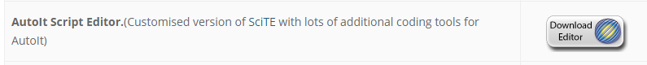

* **Download the above Editor on your system.**
* **Double click on the Setup file.**
* **Follow the default instruction to install autoIT.**

**How Auto IT identifies objects on window popup ?**

* **Elements present on window pop up are known as *CONTROLS*.**
* **In order to inspect these controls, AutoIT uses AutoIT Window Info”.**
* **In order to open “AutoIT Window Info”, navigate to the below path.**

***Go to Start → All Programs →  AutoIT V3 → Select AutoIT Info*.**

* **As a result, the below window opens up.**

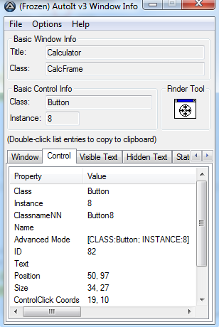

* **In the above image, drag the *“Finder Tool”* option and drop it on any element/control present on the window pop up for which you want to identify the properties.**
* **It will display the properties of the same controls  such as *Class, Name, ID and Text.***
* **These properties are also known as CONTROL ID, using which AutoIT locates elements/controls on window pop up.**
* **General syntax for using single Control ID is :**

***[Control ID : Value]***

* **We can use multiple Control IDs as well using semicolon as the delimiter to identify the controls using below syntax.**

***[ Control ID 1: Value1 ; Control ID 2 : Value2 ; Control ID 3 ; Value3]***

***Steps to write and execute AutoIT script :***

* **Navigate to the below path and open the Editor to write the autoIT script**

**Go to Start → All Programs → AutoIt → Select *SciTE Script Editor***

* **Write the autoIT script and save the file with .au3 extension**
* **Go to Tool → Select Compile. As a result, it will generate an .exe file**
* **Navigate to the folder location where .exe file is located and double click on this .exe file to execute the autoIT script.**
* **We can also execute the script from eclipse by using RunTime class of Java**

**RunTime.getRunTime(“path of the compiled au3.exe file”);**

***Automate the following scenario using AutoIT :***

1. **Navigate to actiTIME login page.**
2. **By default, username text box will be active.**
3. **Press Control + P using Robot class and ensure the print window popup is displayed**
4. **On the Print window, click on Cancel button by using AutoIT**

**Selenium Code:**

**Write the below lines of code in AutoIT editor, save with .au3 extension.**

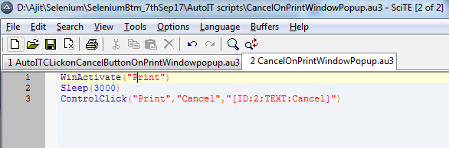

**Go to tools → select compile and as a result, .exe file gets generated.**

**Now, write the below selenium code to run the .exe file**

**public class AutoIT_Example {**

**public static void main(String[] args) throws InterruptedException, AWTException, IOException {**

**System.setProperty("webdriver.gecko.driver", ".\\driver\\geckodriver.exe");**

**WebDriver driver = new FirefoxDriver();**

**driver.get("http://localhost:8080/login.do");**

**Thread.sleep(3000);**

***//Press Control + P from keyboard using Robot class***

**Robot r = new Robot();**

**r.keyPress(KeyEvent.VK_CONTROL);**

**r.keyPress(KeyEvent.VK_P);**

**r.keyRelease(KeyEvent.VK_P);**

**r.keyRelease(KeyEvent.VK_CONTROL);**

***//Using Runtime class, to run the .exe file***

**Runtime run = Runtime.getRuntime();**

**run.exec("D:\\Ajit\\Selenium\\SeleniumBtm_7thSep17\\AutoIT scripts\\CancelOnPrintWindowPopup.exe");**

**//close the browser**

**driver.close();**

**}}**

***Summary of the different popups in selenium and how to handle those is mentioned below.***

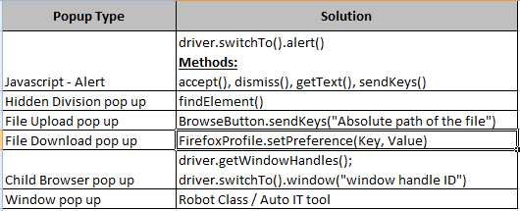

**what is findElements() ?**

* **findElements() method is present in SearchContext interface, the super most interface in Selenium.**
* **findElements() identifies the elements on the webpage based on the locators used.**
* **It returns a list of webElements if it find the matching element.**
* **If it does not find any matching web element on the web page, it returns an empty list.**

**Program :**

**Write a script to find the total number of links, number of visible links and number of hidden links present on actitime login page.**

**Selenium Code :**

**public class findElements_Example extends BaseClass {**

**public static void main(String[] args) throws InterruptedException {**

**driver.get("http://localhost:8080/login.do");**

***//findElements() method returns list of web element***

**List<WebElement> allLinks = driver.findElements(By.tagName("a"));**

***//get the total number of link elements***

**int totalLinks = allLinks.size();**

**System.out.println("total number of links present on the web page is : "+totalLinks);**

**int visibleLinkCount = 0;**

**int hiddenLinkCount = 0;**

***//using foreach loop, iterate through all the links***

**for (WebElement link : allLinks) {**

***//if the link is displayed, then print the text of the link***

**if (link.isDisplayed()) {**

**visibleLinkCount++;**

**System.out.println(visibleLinkCount+" --> "+link.getText());**

**}else{**

**hiddenLinkCount++;**

**}**

**}**

**System.out.println("Total number of visible links :" + visibleLinkCount);**

**System.out.println("Total number of hidden links :" + hiddenLinkCount);**

**driver.close();**

**}}**

**Assignment :**

**Automate the following scenario**

* **Login in to actitime**
* **click on Tasks**
* **Count the total number of checkbox present on the page**
* **Select all the checkbox**
* **Deselect all the checkboxes in reverse order**
* **Select first and last checkbox**

**Selenium Code:**

**Copy code here.**

**WebTable :**

**Table present on the web page is called WebTable.**

**Create a webtable as shown below.**

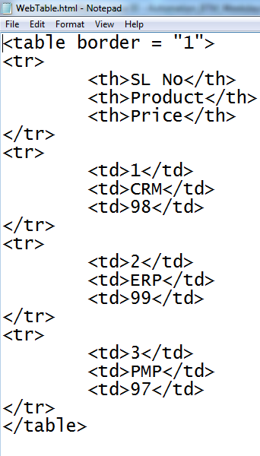

**The webpage looks like this as shown below.**

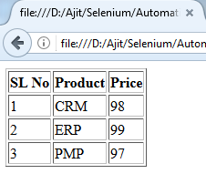

**Program :**

**In the below webtable, find the following scenarios :**

* **print the total number of ROWS present**
* **print the total number of COLUMNS present**
* **print the total number of CELLS present**
* **print ONLY the NUMERIC values present**
* **Count the TOTAL number of NUMERIC values present**
* **print the SUM of all the numeric values in the table**

**Selenium Code:**

**public class WebTable_Example extends BaseClass{**

**public static void main(String[] args) {**

**driver.get("D:\Ajit\Selenium\SeleniumBtm_7thSep17\webpages\WebTable.html");**

***//Count Total number of rows present in the table***

**List<WebElement> allRows = driver.findElements(By.xpath("//tr"));**

**int totalRows = allRows.size();**

**System.out.println("total number of rows present in the table is :"+ totalRows);**

***//count total number of columns***

**List<WebElement> allColumns = driver.findElements(By.xpath("//th"));**

**int totalColumns = allColumns.size();**

**System.out.println("Total number of columns in the table is :" + totalColumns);**

***//Count number of cells present in the table***

**List<WebElement> allCells = driver.findElements(By.xpath("//th|//td"));**

**int totalCells = allCells.size();**

**System.out.println("Total number of cells present in the table is :" + totalCells);**

***//Print ONLY the numbers***

**int countNumberValue = 0;**

**int sum=0;**

**for (WebElement cell : allCells) {**

**String cellValue = cell.getText();**

**try{**

**int number = Integer.parseInt(cellValue);**

**System.out.print(“ ”+number);**

**countNumberValue++;**

**sum = sum+number;**

**}catch (Exception e) {**

**}**

**}**

**System.out.println("Total count of numeric values is :"+countNumberValue);**

**System.out.println("Total sum of all the numeric values is :"+sum);**

***//close the browser***

**driver.close();**

**}**

**}**

**Assignment :**

**Write a script to verify that the sum of marks present in the below table is same as the Total marks.**

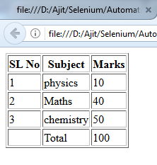

**HTML code to create the sample webpage is below.**

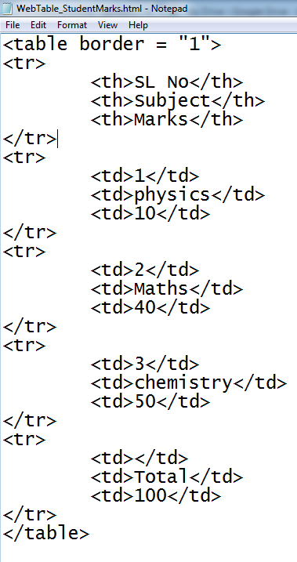

**Selenium Code :**

**copy the code here.**

**How to handle Auto Suggestion list box ?**

**Answer : Using findElements() method**

**Program :**

**Automate the following scenario :**

* **Navigate to google page**
* **Enter Selenium in google search text box**
* **Print the list of auto suggestion values**
* **Click on a specified link  ( Selenium Interview Questions) displayed in the dropdown**

**Selenium Code :**

**public class AutosuggestionEx_GoogleSearch extends BaseClass{**

**public static void main(String[] args) throws InterruptedException {**

**driver.get("**[**http://www.google.com**](http://www.google.com)**");**

***//Enter Selenium in google search text box***

**driver.findElement(By.id("lst-ib")).sendKeys("selenium");**

**Thread.sleep(2000);**

**List<WebElement> allOptions = driver.findElements(By.xpath("//*[contains(text(),'selenium')]"));**

**int count = allOptions.size();**

**System.out.println(“Number of values present in the dropdown is : ” + count);**

**String expectedValue="selenium interview questions";**

***//Print all the auto suggestion values***

**for (WebElement option : allOptions) {**

**String text = option.getText();**

**System.out.println("   "+text);**

***//Click on Java Interview Questions***

**if (text.equalsIgnoreCase(expectedValue)) {**

**option.click();**

**break;**

**}**

**}**

**How to select List Box ?**

* **In Selenium, we handle listbox using Select class.**
* **Select class is present in org.openqa.selenium.support.ui package.**
* **Select class has a parameterized constructor which accepts an argument of WebElement object (List box element)**
* **Following are the available methods of Select class**
* **selectByIndex()**
* **selectByValue()**
* **selectByVisibleText()**
* **deSelectByIndex()**
* **deSelectByValue()**
* **deSelectByVisibleText()**
* **isMultiple()**
* **getOptions()**
* **getAllSelectedOptions()**
* **getFirstSelectedOption()**
* **deSelectAll()**
* **We can use the following deSelect() methods only on multi select listbox. If we try to use it on single select list box, then it throws *UnsupportedOperationException***
* **deSelectByIndex()**
* **deSelectByValue()**
* **deSelectByVisibleText()**
* **deSelectAll()**

**Program:**

**Write a script to select few elements in the list box.**

**Create a sample webpage**

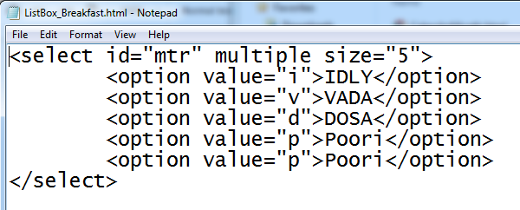

**Selenium Code :**

**public class ListBoxExample extends BaseClass{**

**public static void main(String[] args) {**

**driver.get("file:///D:/Ajit/Selenium/SeleniumBtm_7thSep17/webpages/ListBox_Breakfast.html");**

**WebElement list = driver.findElement(By.id("mtr"));**

***//Create an object of Select class and pass the address of list box as an argument***

**Select s = new Select(list);**

***//getOptions() method returns a list of all the elements of the list box***

**List<WebElement> options = s.getOptions();**

**int size = options.size();**

**System.out.println("Number of elements present inside the listbox is : "+ size);**

***//Print all the elements present in the list box***

**for (WebElement webElement : options) {**

**String text = webElement.getText();**

**System.out.println(text);**

**}**

***//selectByIndex() selects an element based on the Index, here index starts with 0***

**s.selectByIndex(0);**

***//selectByValue() method selects an element based on its value attribute.***

**s.selectByValue("v");**

***/*selectByVisibleText() method selects an element based on the actual text that is visible to the user. For instance, if there are multiple Poori present inside the listbox , it will select all the Poori elements.*/***

**s.selectByVisibleText("Poori");**

***System.out.println("************Print all selected options***********");***

**List<WebElement> allSelectedOptions = s.getAllSelectedOptions();**

**int size2 = allSelectedOptions.size();**

**System.out.println("Number of items that is selected in the list box is : "+size2);**

***System.out.println(" Selected items are printed below ");***

**for (WebElement webElement : allSelectedOptions) {**

**System.out.println(webElement.getText());**

**}**

***System.out.println("check whether it is a multiple select listbox or not");***

**boolean multiple = s.isMultiple();**

**System.out.println(multiple +" yes , it is multi select");**

**if (multiple) {**

***//Print the first selected option in the list box***

**WebElement firstSelectedOption = s.getFirstSelectedOption();**

**System.out.println(firstSelectedOption.getText()+" is the first selected item in the list box");**

***//deselect the item present in 0th index.***

**s.deselectByIndex(0);**

***//Print the first selected option in the list box***

**WebElement firstSelectedOption1 = s.getFirstSelectedOption();**

**System.out.println(firstSelectedOption1.getText()+" is the first selected item");**

***//deselect an item which has an attribute called value and its value is "v"***

**s.deselectByValue("v");**

***//Print the first selected option in the list box***

**WebElement firstSelectedOption2 = s.getFirstSelectedOption();**

**System.out.println(firstSelectedOption2.getText()+" is the first selected item");**

**s.deselectByVisibleText("Poori");**

**}**

**}**

**}**

**Program:**

**Write a script to print the content of the list box in sorted order.**

**Selenium Code :**

**public class PrintListValues_SortedOrder extends BaseClass{**

**public static void main(String[] args) throws InterruptedException {        driver.get("file:///D:/Ajit/Selenium/SeleniumBtm_7thSep17/webpages/ListBox_Breakfast.html");**

**WebElement listElement = driver.findElement(By.id("mtr"));**

**Select s = new Select(listElement);**

**List<WebElement> allOptions = s.getOptions();**

**int count = allOptions.size();**

**System.out.println(count);**

***System.out.println("-----print the values in the list ----");***

**ArrayList<String> list = new ArrayList<String>();**

**for (WebElement option : allOptions) {**

**String text = option.getText();**

**System.out.println(text);**

**list.add(text);**

**}**

**Collections.sort(list);**

***System.out.println("-----print the value in sorted order----");***

**for (String value : list) {**

**System.out.println(value);**

**}}}**

**Program:**

**Write a script to print the UNIQUE content of the list box.**

***Hint : Use HashSet<>***

**Selenium Code :**

**public class printUniqueElementinthelistbox  extends BaseClass{**

**public static void main(String[] args) throws InterruptedException {**

**driver.get("file:///D:/Ajit/Selenium/SeleniumBtm_7thSep17/webpages/ListBox_Breakfast.html");**

**WebElement listElement = driver.findElement(By.id("mtr"));**

**Select s = new Select(listElement);**

**List<WebElement> allOptions = s.getOptions();**

**int count = allOptions.size();**

**System.out.println(count);**

**System.out.println("-----print the values in the list ----");**

**HashSet<String> allElements = new HashSet<String>();**

**for (WebElement option : allOptions) {**

**String text = option.getText();**

**System.out.println(text);**

**allElements.add(text);**

**}**

**System.out.println(allElements);**

**}**

**}**

**Program:**

**Write a script to print the UNIQUE content of the list box in  SORTED order.**

***Hint : Use TreeSet<>***

**Selenium Code :**

**public class printUniqueElement_Sorted  extends BaseClass{**

**public static void main(String[] args) throws InterruptedException {**

**driver.get("file:///D:/Ajit/Selenium/SeleniumBtm_7thSep17/webpages/ListBox_Breakfast.html");**

**WebElement listElement = driver.findElement(By.id("mtr"));**

**Select s = new Select(listElement);**

**List<WebElement> allOptions = s.getOptions();**

**int count = allOptions.size();**

**System.out.println(count);**

**System.out.println("-----print the values in the list ----");**

***TreeSet<String> allElements = new TreeSet<String>();***

**for (WebElement option : allOptions) {**

**String text = option.getText();**

**System.out.println(text);**

**allElements.add(text);**

**}**

**System.out.println(allElements);**

**}**

**}**

**Program:**

**Write a script to check whether listbox has duplicate or not ?**

**Selenium Code :**

**public class checklisthasDUPLICATEvalues_HashSet  extends BaseClass{**

**public static void main(String[] args) {**

**driver.get("file:///D:/Ajit/Selenium/AutomationByBhanuSir_BTM/testdataFiles/ListBox_Breakfast.html");**

**WebElement listbox = driver.findElement(By.id("mtr"));**

**Select s = new Select(listbox);**

**List<WebElement> allOptions = s.getOptions();**

**int count1 = allOptions.size();**

**System.out.println("Number of elements in the list is :" +count1);**

**HashSet<String> allElementText = new HashSet<String>();**

**for (int i = 0; i < count1; i++) {**

**String text = allOptions.get(i).getText();**

**System.out.println(text);**

**allElementText.add(text);**

**}**

**int count2 = allElementText.size();**

**System.out.println("Number of elements in the hashset is :" +count2);**

**if (count1==count2) {**

**System.out.println("list box has NO duplicate values");**

**}**

**else{**

**System.out.println("list box has  duplicate values");**

**}**

**System.out.println(allElementText);**

**driver.close();**

**}}}**

**Program:**

**Write a script to print the duplicate item in the list ?**

**Selenium Code :**

**public class PrinttheDUPLICATEItem_intheList_HashSet  extends BaseClass{**

**public static void main(String[] args) {**

**driver.get("file:///D:/Ajit/Selenium/AutomationByBhanuSir_BTM/testdataFiles/ListBox_Breakfast.html");**

**WebElement listbox = driver.findElement(By.id("mtr"));**

**Select s = new Select(listbox);**

**List<WebElement> allOptions = s.getOptions();**

**int count1 = allOptions.size();**

**System.out.println("Number of elements in the list is :" +count1);**

**HashSet<String> allElementText = new HashSet<String>();**

**for (int i = 0; i < count1; i++) {**

**String text = allOptions.get(i).getText();**

***/*allElementText.add(text) returns true if the element is not already added, and it returns false if the same element is trying to be added twice.  */***

**if (!allElementText.add(text)) {**

**System.out.println(text +" is the duplicate item in the list box");**

**}**

**}**

**System.out.println(allElementText.size());**

***// it will print all the unique values in the HashSet object***

**System.out.println(allElementText);**

**driver.close();**

**}**

**}**

**\*\*\*\*\*\*\*\*\*\*\*\*\*\*\*\*\*\*\*\*\*\*\*\*\*\*\*\*\*\*\*\*\*\*\*\*\*\*\*\*\*\*\*\*\*\*\*\*\*\*\*\*\*\*\*\*\*\*\*\*\*\*\*\*\*\*\*\*\*\*\*\*\*\*\*\***

***List of Exceptions***

**\*\*\*\*\*\*\*\*\*\*\*\*\*\*\*\*\*\*\*\*\*\*\*\*\*\*\*\*\*\*\*\*\*\*\*\*\*\*\*\*\*\*\*\*\*\*\*\*\*\*\*\*\*\*\*\*\*\*\*\*\*\*\*\*\*\*\*\*\*\*\*\*\*\*\*\***

1. IllegalStateException [Java - Unchecked] (driver exe path not set)
2. InterruptedException [Java - Checked   ]  (Thread.sleep)
3. IOException[Java-Checked][File handling scenario]
4. AWTException [Abstract Window Toolkit] [java -  checked] [While handling Robot object]
5. NoSuchElementException[Selenium - unchecked][unable to locate the element]
6. JavascriptException[Selenium-Unchecked][on clicking on a button using submit() and the button don’t have an attribute called type=’submit’]
7. NoSuchFrameException[Unchecked - selenium] [when specified frame is not present on the webpage]
8. NoSuchWindowException[Unchecked - selenium]  no such window: target window already closed
9. NoAlertPresentException [Selenium - unchecked] [When no alert is present]
10. NoSuchSessionException: Session ID is null [Unchecked - Selenium] when driver.quit is called and then you are trying to access any browser